
eAEO-STP

User Guide
2021

Table of contents
1. Introduction 3
2. Common Features 4
3. Submitted Applications 5
3.1. Consultation 6
3.2. New submitted application 9
3.3. Amendment 12
3.4. Withdrawal 15
3.5. Additional information 17
3.6. Clone 19
3.7. Request AEOF 21
4. AEO Applications 23
4.1. Consultation 24
4.2. Amendment 27
4.3. Withdrawal 30
4.4. Additional information 32
4.5. Adjustments 34
4.6. Right to be heard 38
5. AEO Authorisations 40
5.1. Consultation 41
5.2. Amendment 44
5.3. Suspension & Take Measures 46
5.3.1. Proposed measures 47
5.3.2. Measures taken 51
5.3.3. Take measures extension 53
5.4. Revocation 55
5.5. Provide information which may influence the continuation of the decision 57
5.6. Right to be heard 59

1. Introduction
EU Trader Portal for eAEO (eAEO-STP) aims at being the central point accessed by the Traders (or their representatives), identified by an EORI number, for managing the AEO business. More precisely, eAEO-STP is a module installed in the EU Common Trader Portal (EUCTP) providing users with functionalities dedicated to the consultation and the management of their Economic Operator (EO) data.

EO data from eAEO-STP is sent and stored in EOS, the back-office application used by the Customs Officers.
eAEO-STP must thus communicate with EOS to pass Traders’ actions and data to EOS, but also to receive notifications of actions performed by the Customs Officers or requests (like request for Additional information) from the Customs Officers in the back-office.

The services offered to the Traders by eAEO-STP are the submission of new Submitted Applications but also the consultation and management of those Submitted Applications, consultation and management of the AEO Applications and the AEO Authorisations.

To become an AEO, a Trader must submit an application (Submitted Application). When the Receiving Customs Authority verifies that the Submitted Application meets the specific conditions and accepts it, it will become an AEO Application. If the Trader meets the criteria to become an AEO, the AEO Authorisation will be issued by the Decision Taking Customs Authority. There could be only one valid AEO Authorisation at a given time for an EO.

The current user manual presents the different pages accessible to the Traders or their representatives for managing the AEO data. The actions that can be taken on this data and the way they are displayed in every page are also described.

2. Common Features

The following elements are common to multiple pages of eAEO-STP.

1.Tooltips:
Tooltips are defined next to some fields or boxes of the page in order to help users understanding the displayed information or filling in the form.

2.Mandatory elements:
Mandatory boxes and fields are marked with a *. All mandatory fields must be completed to submit the corresponding form.

3.Common action buttons:
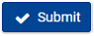Clicking on the "Submit" button triggers the submission of the form to EOS.
In case business validation errors are returned by EOS, a list of errors is displayed on top of the page.
After successful submission, the information sent to EOS can be consulted by the Trader in read-only.

Clicking on the "Save as Draft" button saves the current form and values locally as draft, without validating them and without submitting them to EOS.
A draft can be re-opened, deleted or submitted. In case of successful submission, the draft is automatically deleted.
This action button is only available on some pages.

4.Attachments:
On some pages, users have the possibility to upload files as attachments to the form they want to submit to EOS.

These files are limited to ZIP archives (.zip) and PDF (.pdf). The maximum size is 20MB, the filename can contain up to 100 characters without spaces.

Note that, as the attachments provided by Traders must also be consulted by Customs Authorities in EOS, the EUCTP “Attachments” feature is not used. Instead, the attachments are sent to and saved in EOS. These attachments are therefore consultable directly from the concerned eAEO-STP page(s), but not from the EUCTP “Attachments” page.

3. Submitted Applications

This section details the different pages related to the submitted applications.
3.1. Consultation
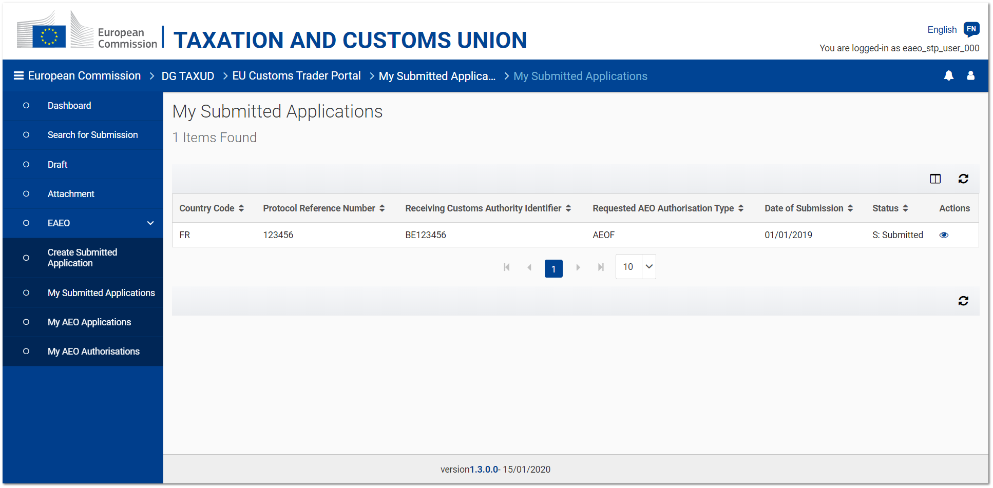
Figure 3.1.1 - My Submitted Applications page

The list of submitted applications linked to a specific EORI can be consulted by the Trader or his/her representative by clicking on eAEO - My Submitted Applications, accessible from the left-hand menu.
Considering that there can be only one ongoing submitted application in all EU, the list consists of the ongoing submitted application and possible previous non valid submitted applications.

Summarized information about every submitted application retrieved from EOS can be seen. From this page, it is possible to consult the details of a specific submitted application.

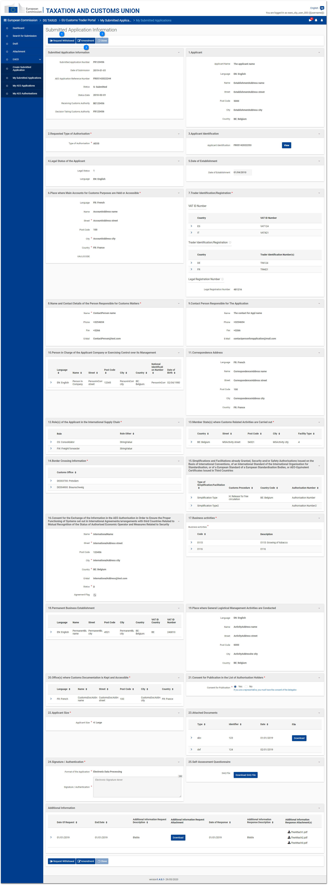
Figure 3.1.2 - Submitted application consultation page

This page displays the details of a submitted application.

Depending on the current status of the consulted submitted application, some actions can be performed on the submitted application:


Request the withdrawal (cf. 3.4. Withdrawal);


Amend (cf. 3.3. Amendment);


Clone the submitted application (cf. 3.6. Clone).

When requested by the Customs Authority, additional information regarding a submitted application may be provided by the Trader or his/her representative (cf. 3.5. Additional information).
This information can be consulted at the bottom of the page, along with the details of the submitted application.

3.2. New submitted application

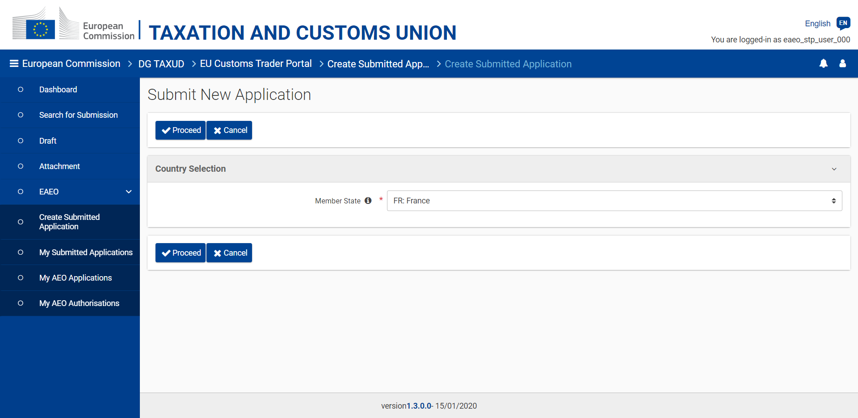
Figure 3.2.1 - Country selection page

The creation of a new submitted application is initiated by clicking on eAEO - Create Submitted Application, from the left-hand menu.
It starts with the selection of the country for which the new application must be created.

By default, the country of the logged-in user (i.e. the Trader or his/her representative) will always be pre-selected based on the EORI information of the user.

The user is not allowed to proceed with the creation of the new submitted application through eAEO-STP in case:
- a National Trader Portal (NTP) exists for the selected country. The URL of the NTP is displayed in the error notification message.
- the legal conditions are not met. No new submitted application can be inserted if the Trader has:
        - already a valid (i.e. with the status "Submitted" or "Pre-accepted") submitted application;
        - a non-reject AEO application without AEO Authorisation;
        - an active (i.e. not suspended and not revoked) AEO authorisation of type AEOF;
  - a revoked AEO authorisation, initiated by the customs authority, for less than 3 years.
The rule(s) that prevent the user to create the submitted application is/are displayed in the error notification message.
Otherwise, the user gets access to the creation page of a new submitted application.

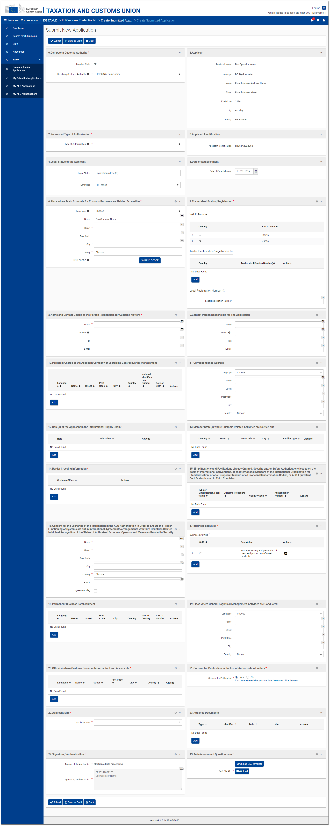
Figure 3.2.2 - New submitted application page

This page allows the Trader to submit a new Submitted Application to a Receiving Customs Authority (RCA) in EOS.

Some fields are automatically populated with the information retrieved from the EORI of the logged-in user.

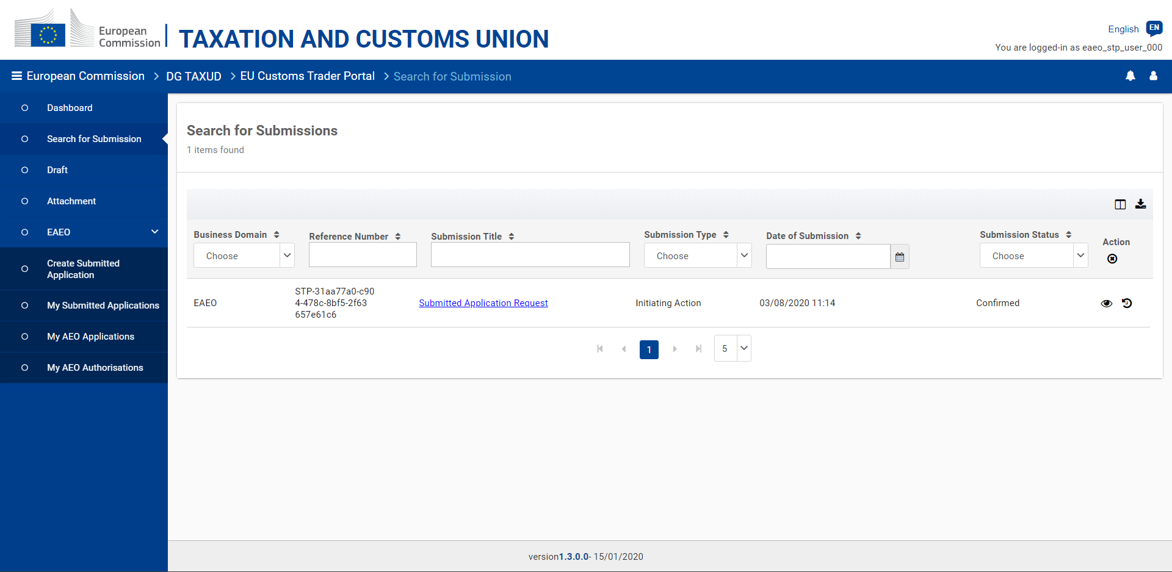
Figure 3.2.3 - New submitted application - View submissions

The submission of a new submitted application can be consulted from the EUCTP "Submissions" menu entry.
3.3. Amendment

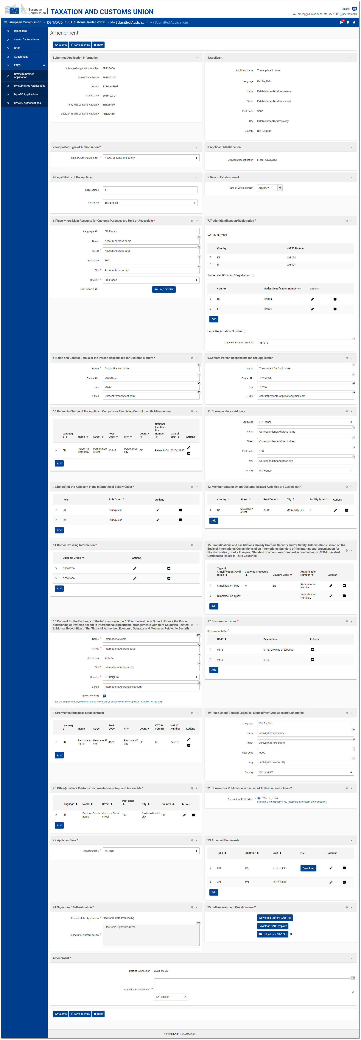
Figure 3.3.1 - Submitted Application Amendment page

The amendment of a submitted application may be submitted under certain conditions – the application has the status "S" (Submitted) and the concerned Member State has no NTP – by clicking on the "Amendment" button from the submitted application consultation page (cf. 3.1. Consultation).

The page displays the same fields as in the creation page and most of them are editable.
An additional box "Amendment" is displayed at the bottom of the page to allow users specifying a justification for the amendment.

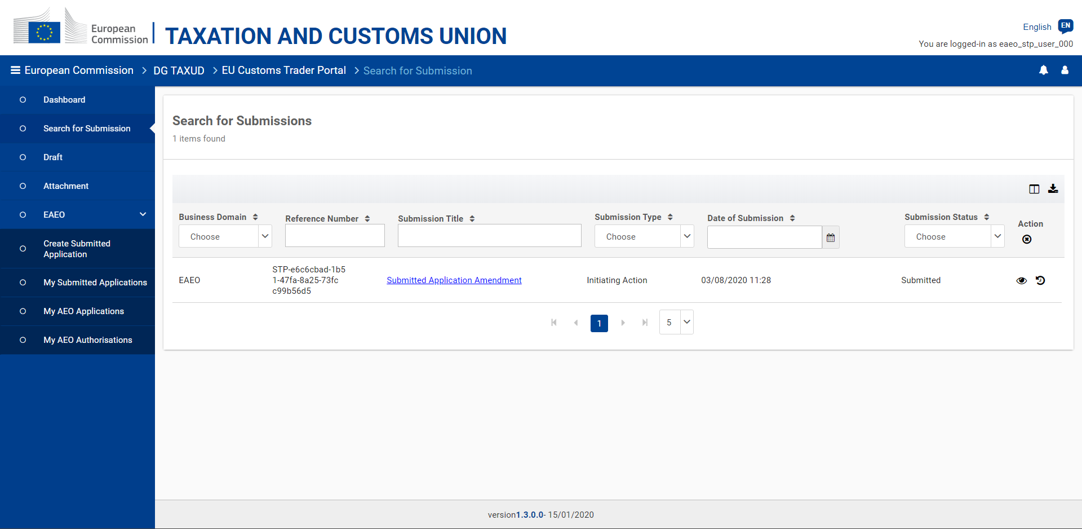
Figure 3.3.2 - Submitted Application Amendment - View submissions

The submission of a submitted application amendment can be consulted from the EUCTP "Submissions" menu entry.

3.4. Withdrawal

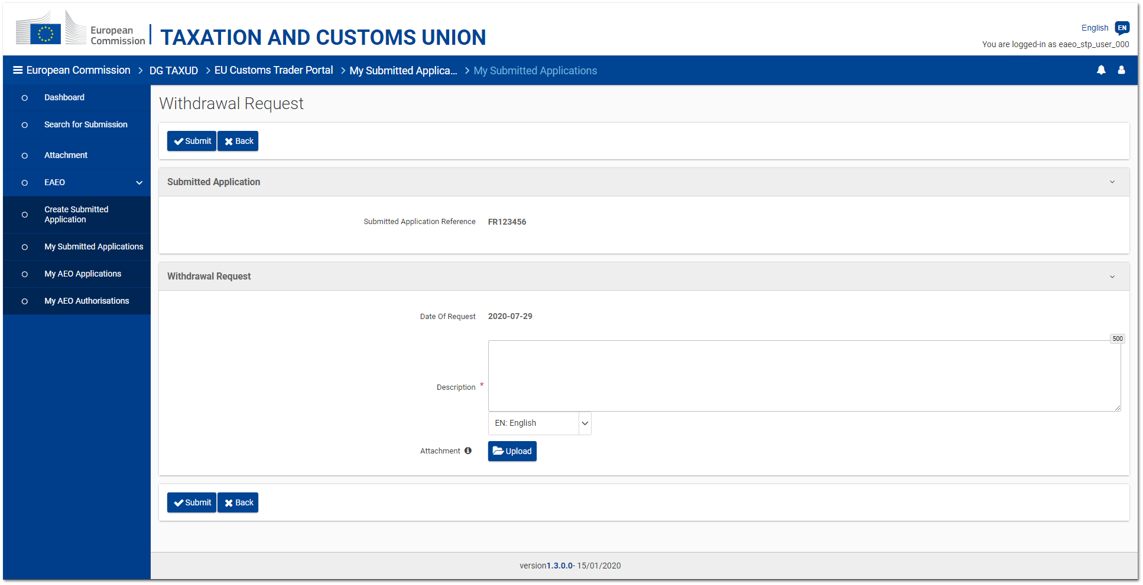
Figure 3.4.1 - Submitted Application Withdrawal request page

The withdrawal of a submitted application may be requested under certain conditions – the application has the status "S" (Submitted) and the concerned Member State has no NTP – by clicking on the "Request withdrawal" button from the submitted application consultation page (cf. 3.1. Consultation).

The page simply displays the reference of the concerned submitted application, a text area and an optional upload button allowing users to provide a justification for the withdrawal request.

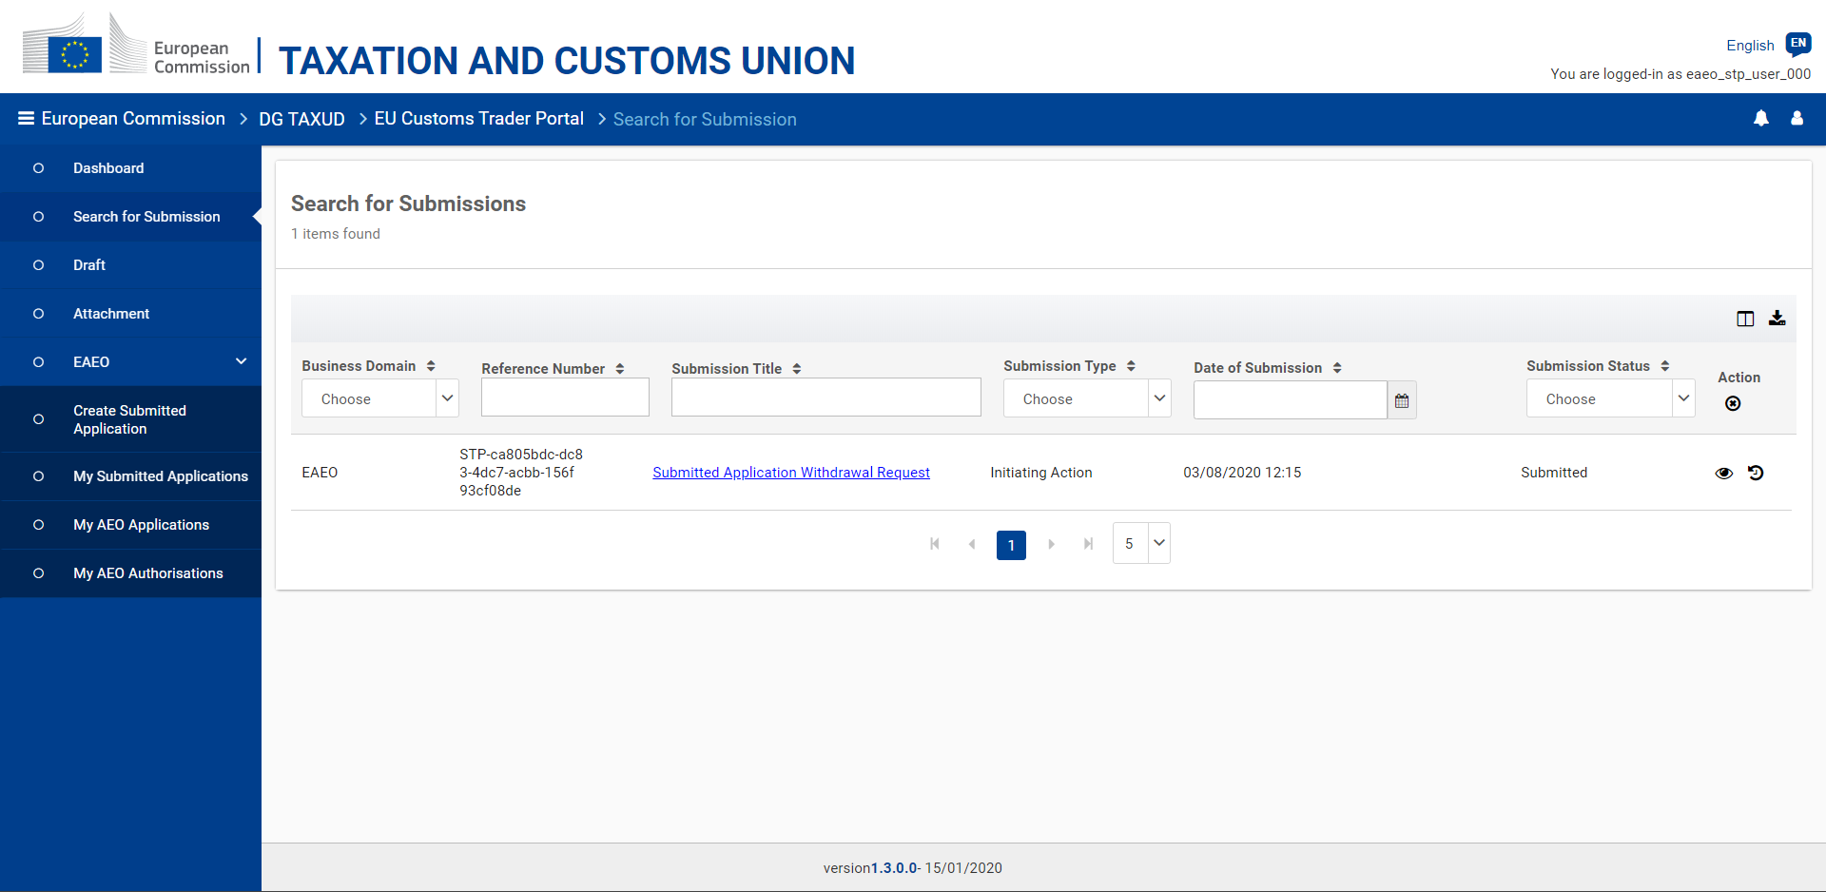
Figure 3.4.2 - Submitted Application Withdrawal request - View submissions

The submission of a submitted application withdrawal request can be consulted from the EUCTP "Submissions" menu entry.

3.5. Additional information

The Trader (or his/her representative) may be requested to provide additional information regarding his/her submitted application by the Receiving Customs Authority (RCA) in EOS.
Such a request for additional information is received in eAEO-STP as a task accessible from the EUCTP "Dashboard" menu entry.

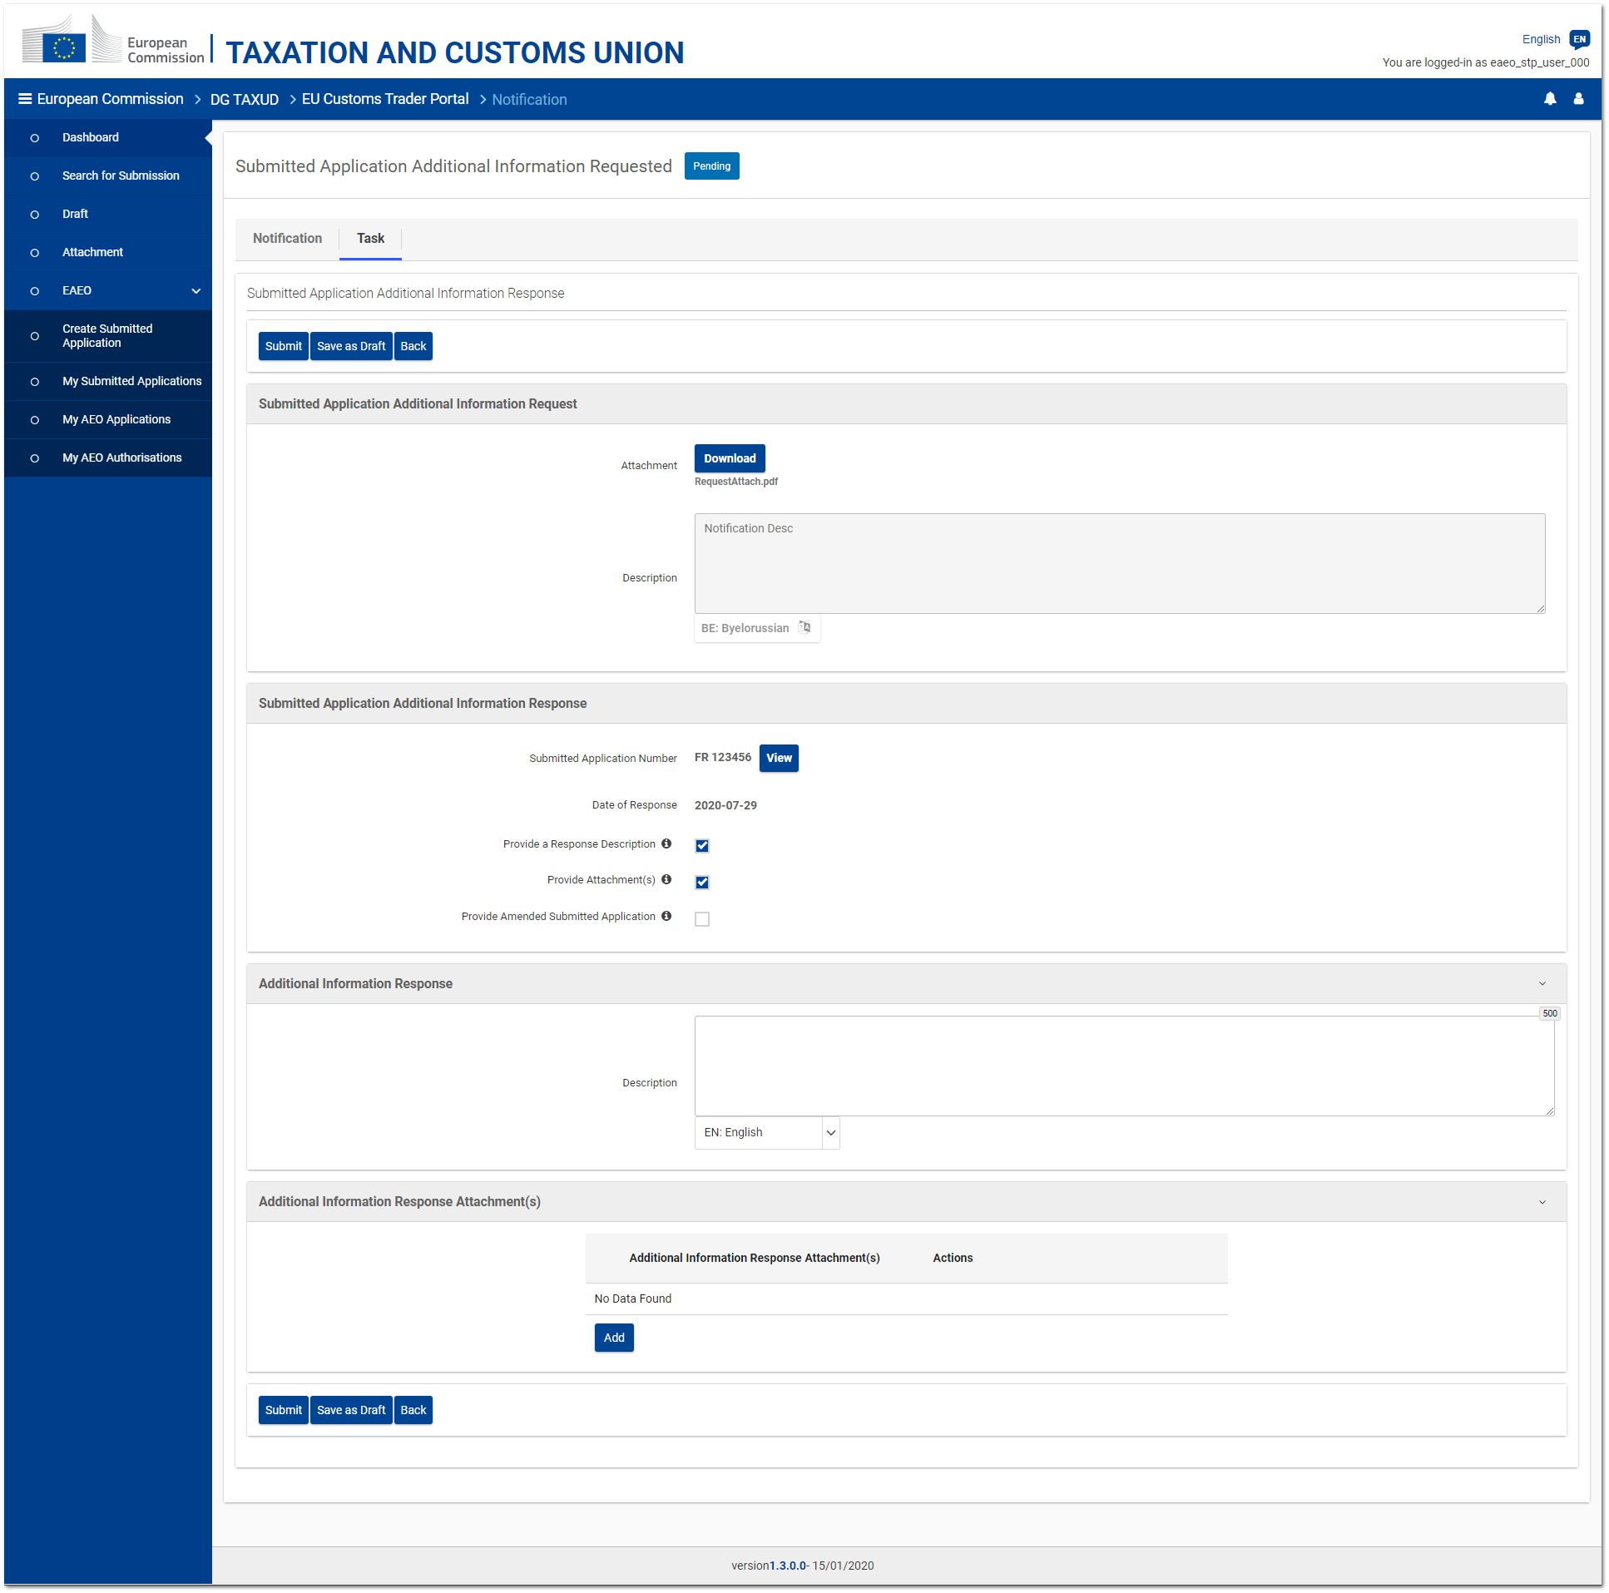
Figure 3.5.1 - Submitted Application Additional information task page

The "Task" tab of the received notification allows the user to provide the requested information in one or more of the following forms:
- A textual description;
- One or several attachments (i.e. files);
- An amended version of the submitted application.
As soon as one option is selected, the corresponding box is expanded. The selected box(es) must be filled in by the user for submitting the response.

A draft can be re-opened (from the EUCTP "Drafts" menu entry), deleted or submitted.
In case of successful submission, the draft is automatically deleted.

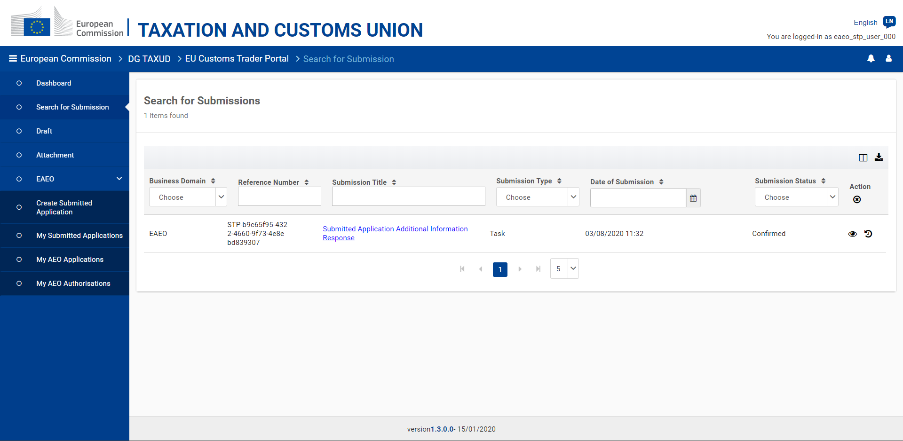
Figure 3.5.2 - Submitted Application Additional Information - View submissions

The response to a submitted application additional information request can be consulted from the submitted task (EUCTP "Dashboard" menu entry) or from the list of submissions (EUCTP "Submissions" menu entry - cf. Figure 3.5.2).
3.6. Clone
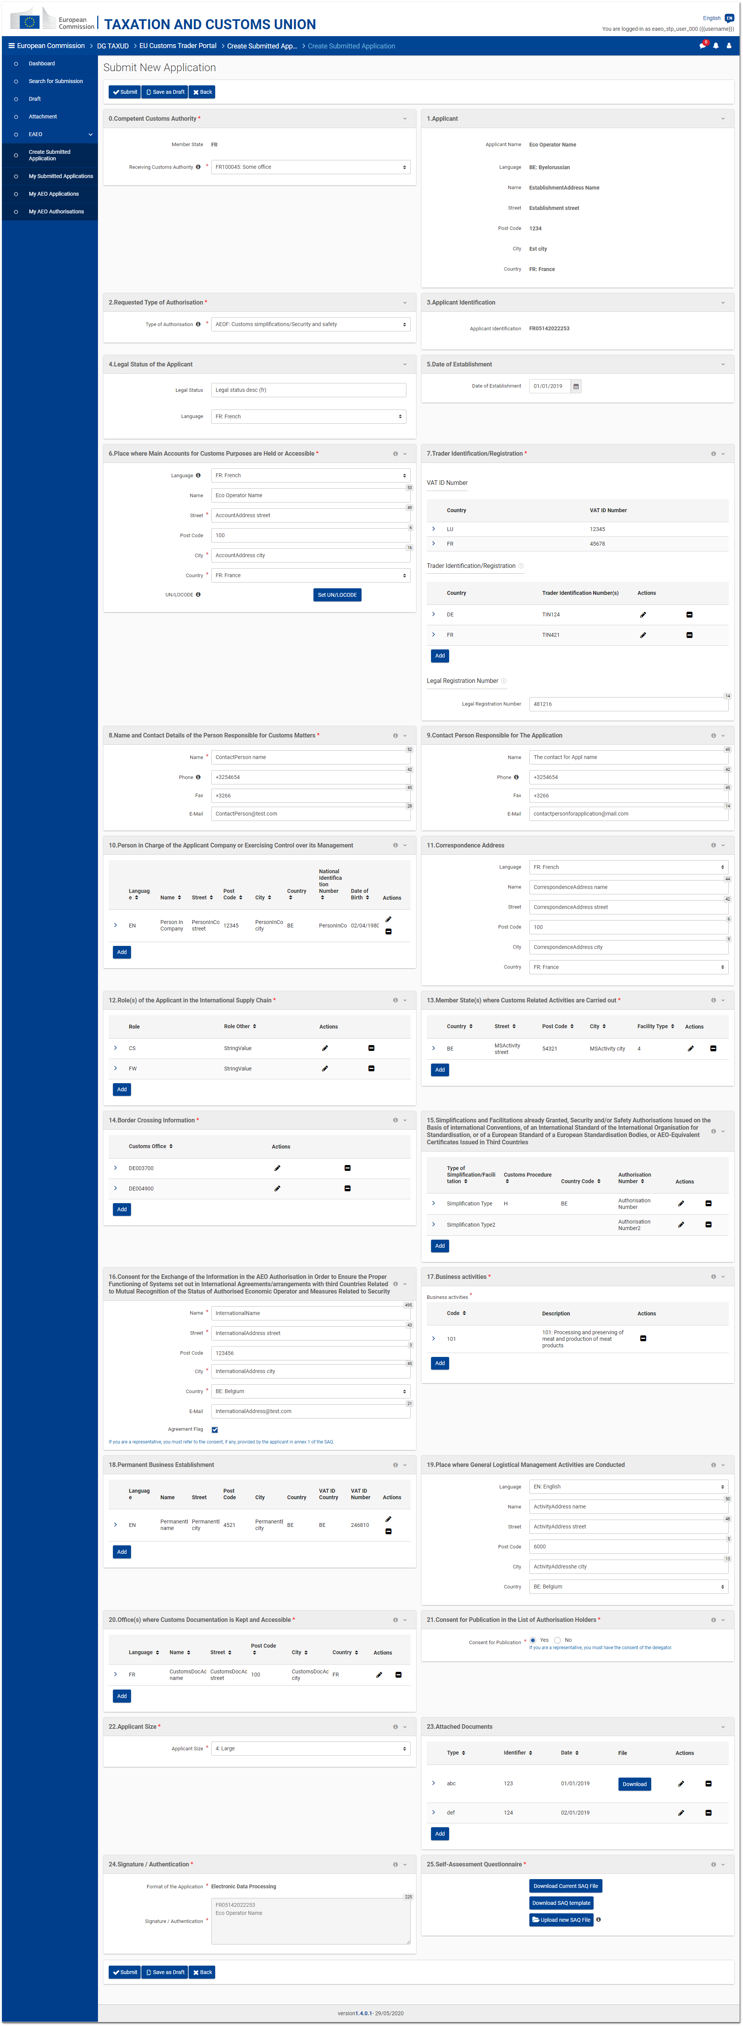
Figure 3.6.1 - Clone submitted application page

The clone of a submitted application may be submitted under certain conditions – the application has the status "N" (Not Accepted) and the concerned Member State has no NTP – by clicking on the "Clone" button from the submitted application consultation page (cf. 3.1. Consultation).

The purpose of this feature is to provide the Trader with the possibility to pre-fill the creation form of the submitted application with the information about another submitted application.

The page is the same as the creation page (cf. 3.2. New Submitted application).
The fields are automatically pre-filled with the information of the submitted application that is cloned and can be modified by the Trader.
The files (including the ones of the box 23 and the SAQ) are also cloned and can be modified by the Trader before submitting the application.

Some fields are also automatically populated with the information retrieved from the EORI of the logged-in user.
3.7. Request AEOF
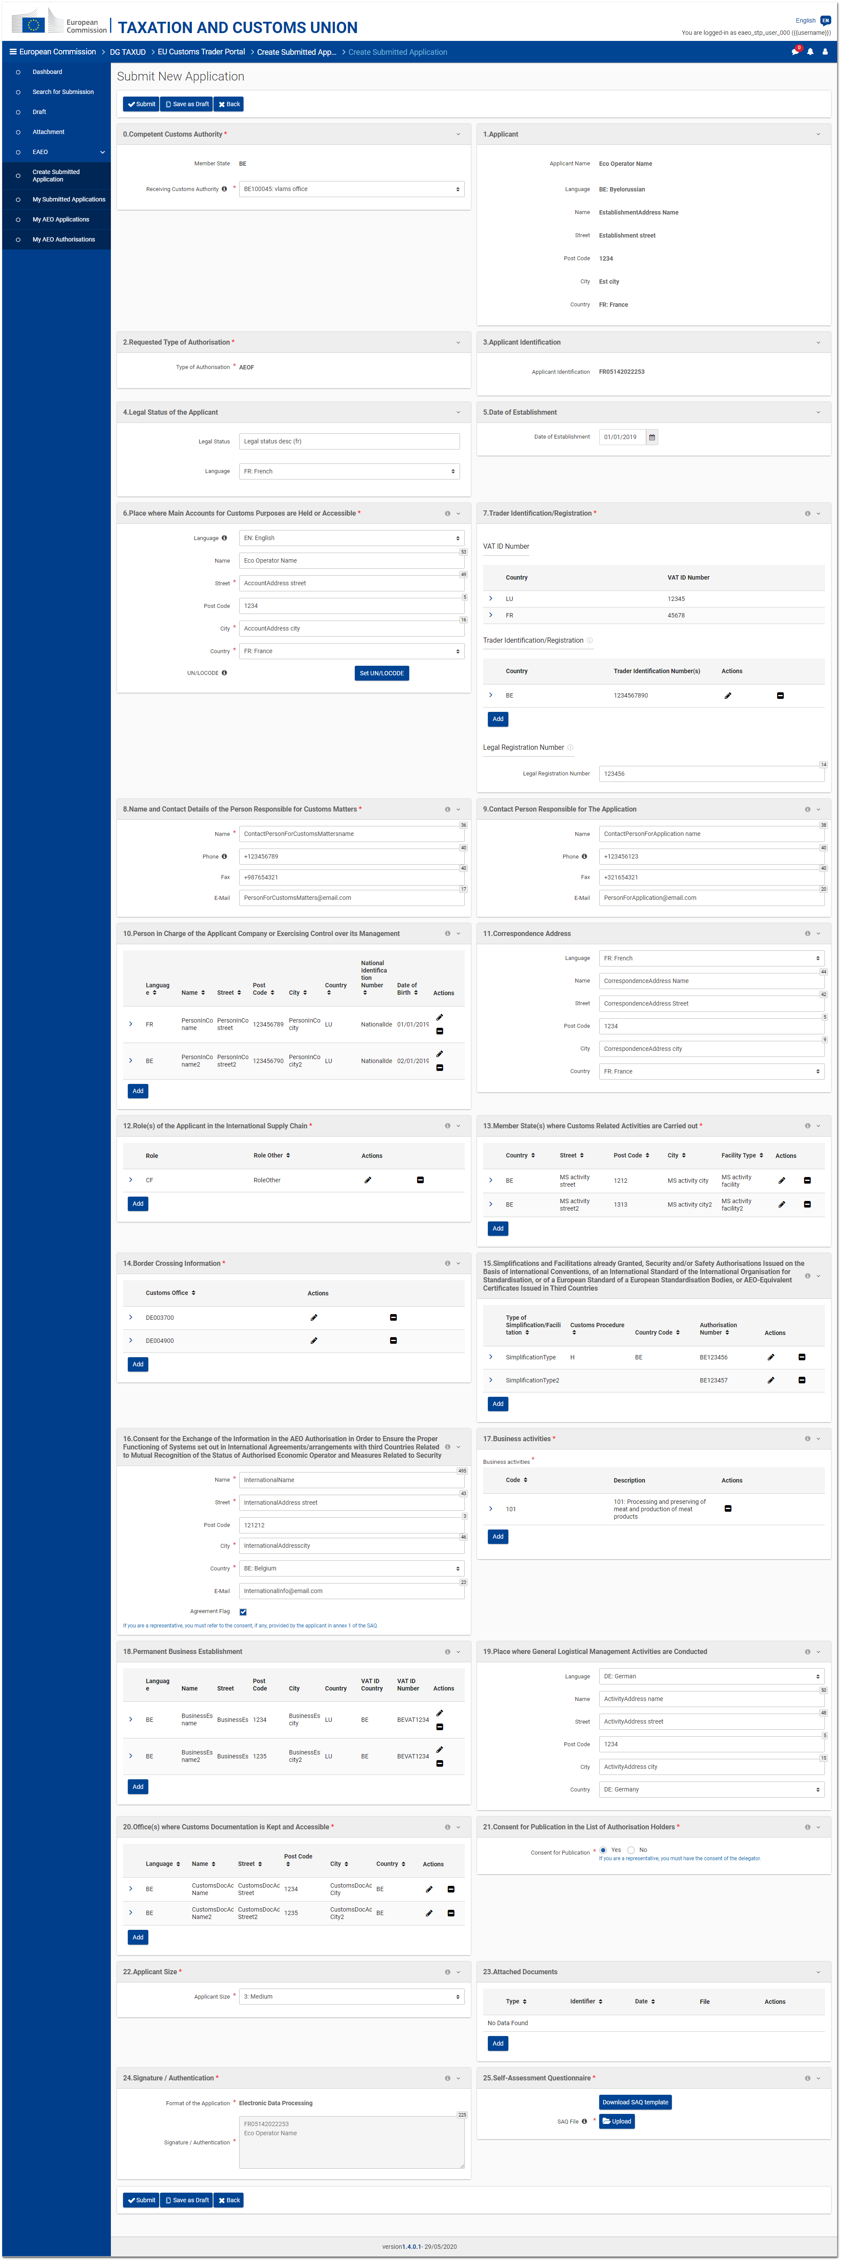
Figure 3.7.1 - New submitted application page (request AEOF)

The upgrade request to the AEOF authorisation type may be submitted under certain conditions – the current AEO authorisation is a valid (i.e. not suspended or revoked) AEOS/AEOC and the concerned Member State has no NTP – by clicking on the "Request AEOF" button from the AEO authorisation consultation page (cf. 5.1. Consultation).

The purpose of this feature is to provide the Trader with the possibility to pre-fill the creation form of the submitted application with information of AEO application from which the current AEO Authorisation of the Trader has been issued.

The page is the same as the creation page of the submitted application (cf 3.2. New Submitted application).
The fields are automatically pre-filled with the information of the AEO application from which the AEO authorisation has been issued and can be modified by the Trader.
The authorisation type is automatically set to "AEOF" and cannot be modified.
The attached documents are not copied from the AEO application.

Some fields are also automatically populated with the information retrieved from the EORI of the logged-in user.
4. AEO Applications

This section details the different pages related to the AEO applications.
4.1. Consultation
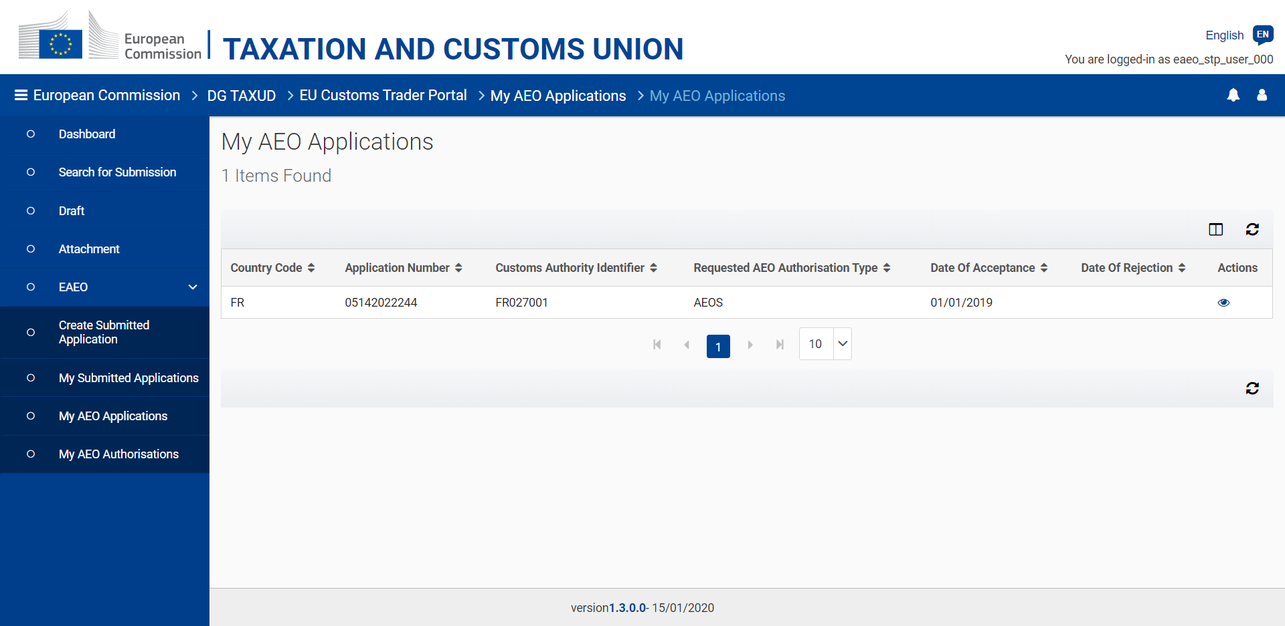
Figure 4.1.1 - My AEO Applications page

The list of AEO applications and possible previously valid applications linked to a specific EORI can be consulted by the Trader or his/her representative by clicking on eAEO - My AEO Applications, accessible from the left-hand menu.
Considering that there can be only one valid AEO application in all EU, the list consists of the ongoing AEO application and possible previous non valid AEO applications.

Summarized information about every AEO application retrieved from EOS can be seen. From this page, it is possible to consult the details of a specific AEO application.

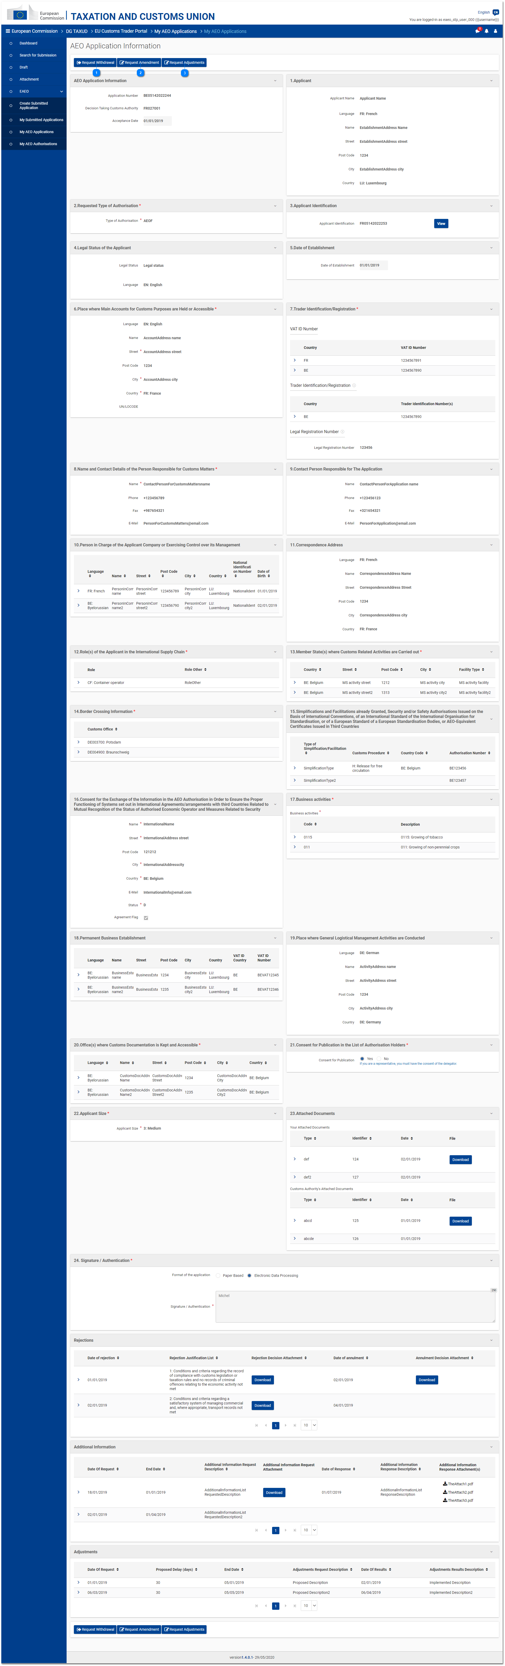
Figure 4.1.2 - AEO application consultation page

This page displays the details of an AEO application, including the possible rejections, additional information and adjustments linked to it.

Depending on the current status of the consulted AEO application, some actions can be performed on it:

Request the withdrawal (cf. 4.3. Withdrawal);

Request an amendment (cf. 4.2. Amendment);

Request adjustments (cf. 4.5. Adjustments).
4.2. Amendment

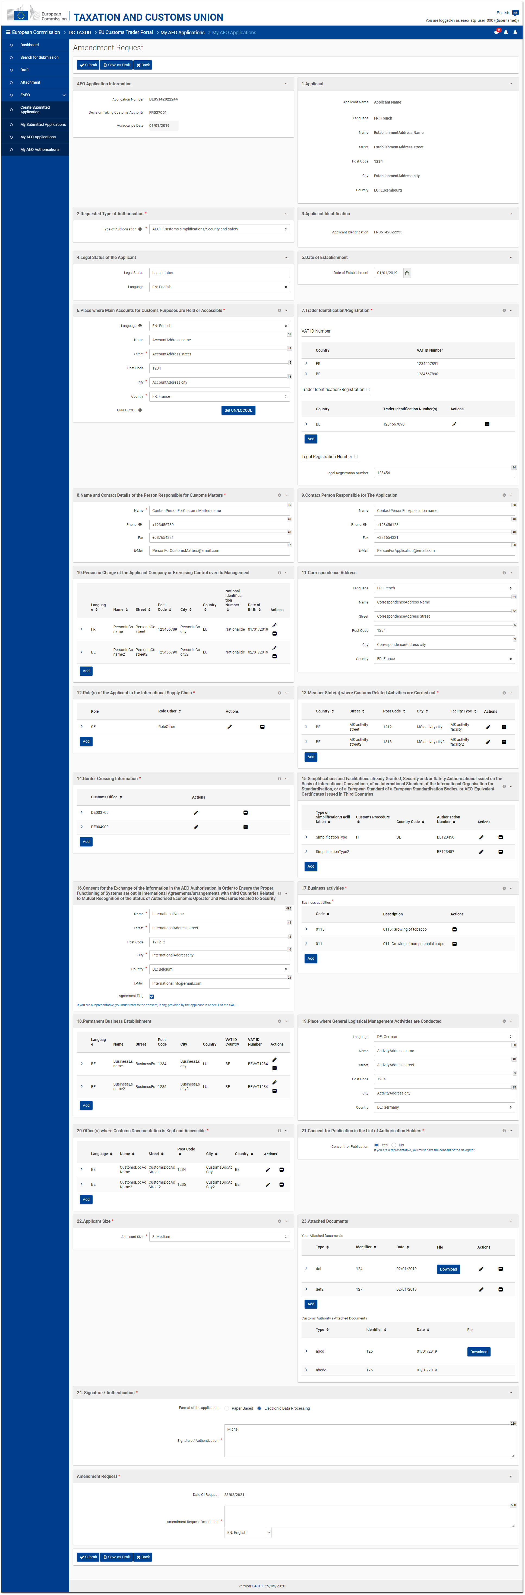
Figure 4.2.1 - AEO Application Amendment request page

The amendment of an AEO application may be requested under certain conditions – the application is valid (i.e. not rejected) and the concerned Member State has no NTP – by clicking on the "Request amendment" button from the AEO application consultation page (cf. 4.1. Consultation).

The page displays the same fields as in the visualisation page and most of them are editable.
An additional box "Amendment Request" is displayed at the bottom of the page to allow users specifying a justification for the amendment request.

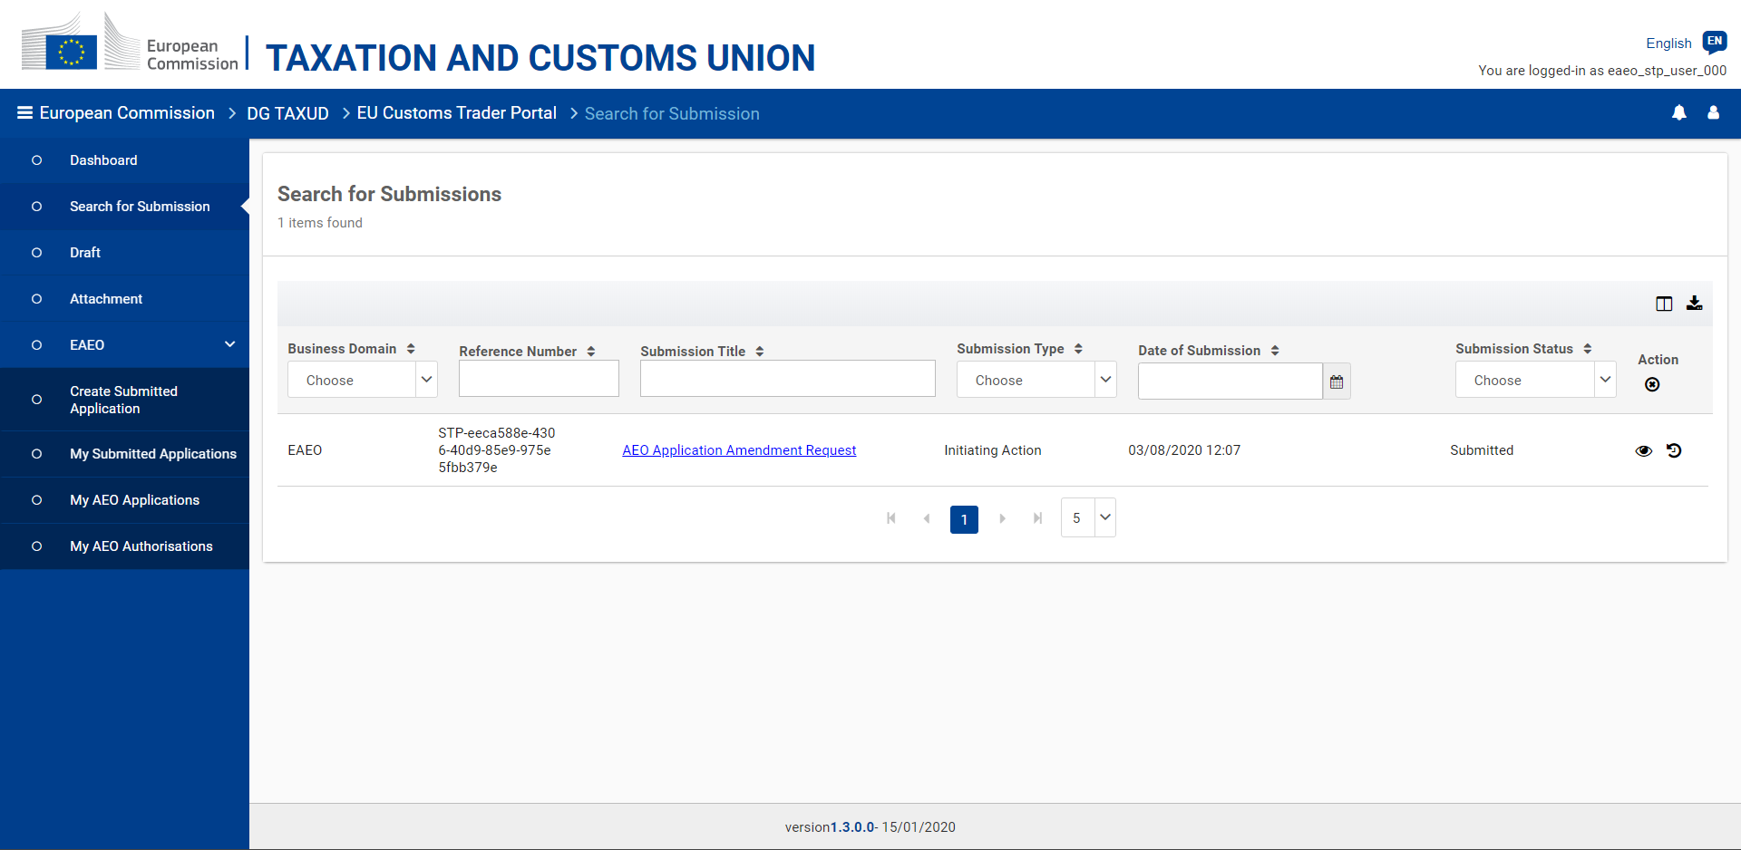
Figure 4.2.2 - AEO Application Amendment request - View submissions

The submission of an AEO application amendment request can be consulted from the EUCTP "Submissions" menu entry.
4.3. Withdrawal

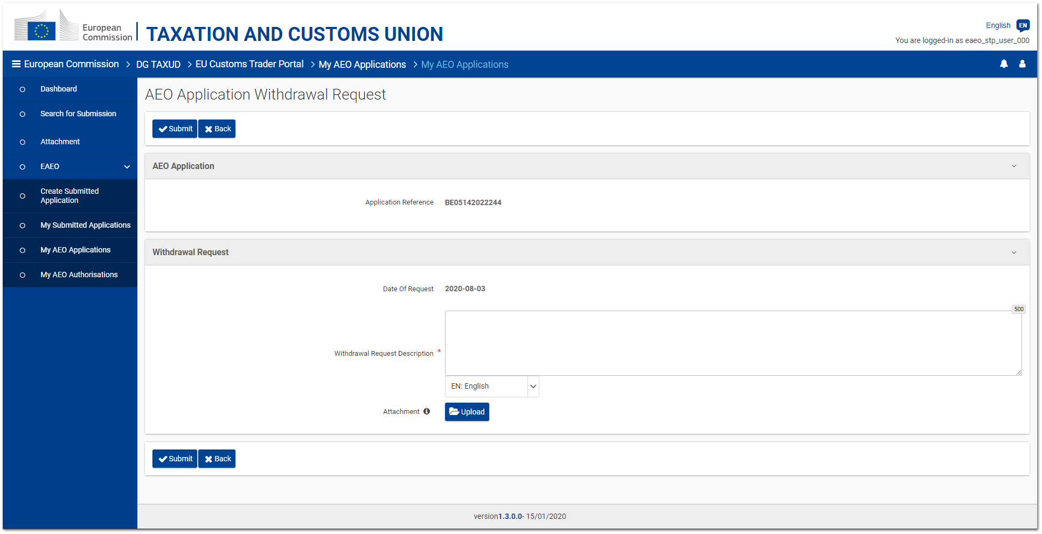
Figure 4.3.1 - AEO Application Withdrawal request page

The withdrawal of an AEO application, namely its rejection, may be requested under certain conditions – the application is valid (i.e. not rejected) and the Trader has no NTP – by clicking on the "Request withdrawal" button from the AEO application consultation page (cf. 4.1. Consultation).

The page simply displays the reference of the concerned AEO application, a text area and an optional upload button allowing users to provide a justification for the withdrawal request.

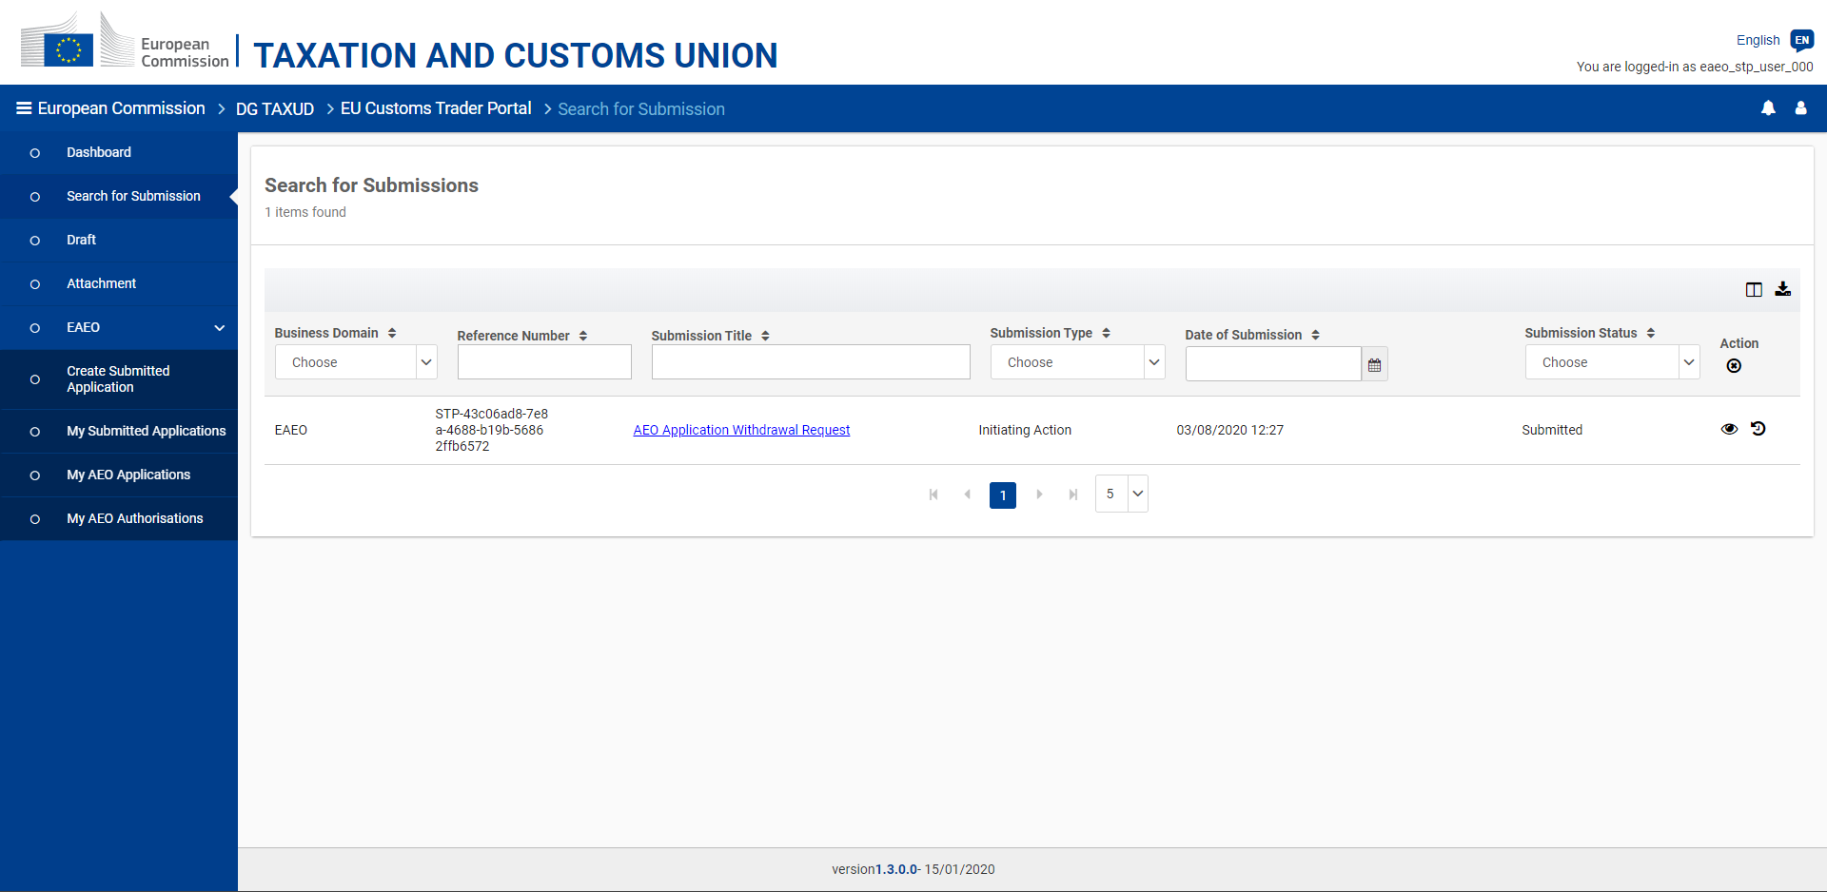
Figure 4.3.2 - AEO Application Withdrawal request - View submissions

The submission of an AEO application withdrawal request can be consulted from the EUCTP "Submissions" menu entry.
4.4. Additional information

The Trader (or his/her representative) may be requested to provide additional information regarding his/her AEO application by the Decision-Taking Customs Authority (DTCA) in EOS.
Such a request for additional information is received in eAEO-STP as a task accessible from the EUCTP "Dashboard" menu entry.

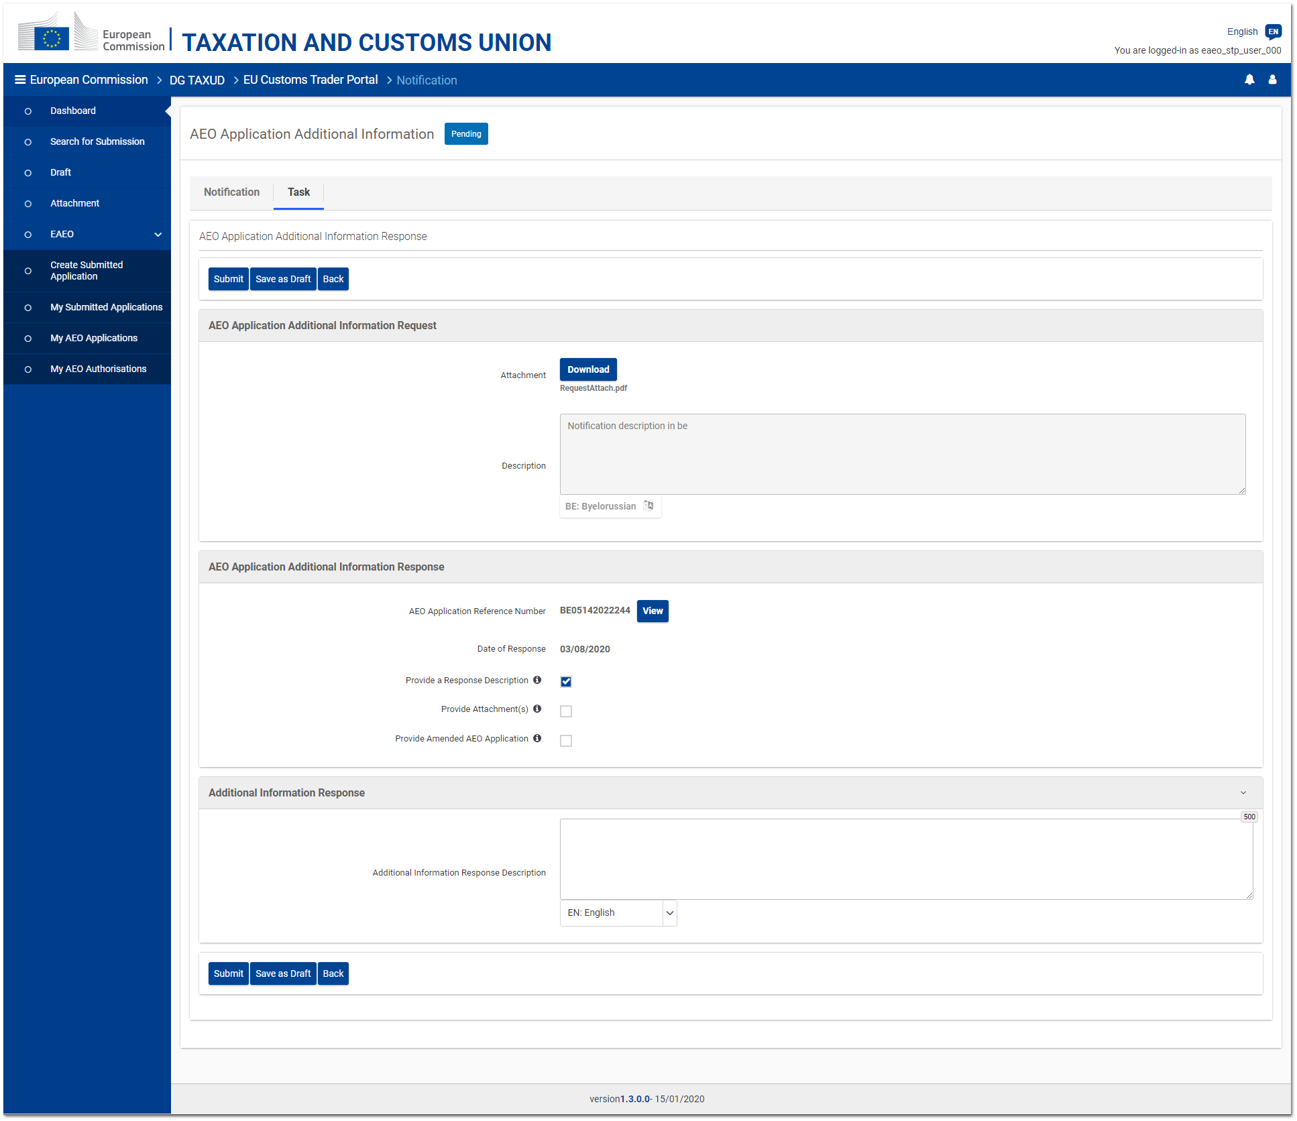
Figure 4.4.1 - AEO Application - Additional information task page

The "Task" tab of the received notification allows the user to provide the requested information in one or more of the following forms:
- A textual description;
- One or several attachments (i.e. files);
- An amended version of the AEO application.
As soon as one option is selected, the corresponding box is expanded. The selected box(es) must be filled in by the user for submitting the response.

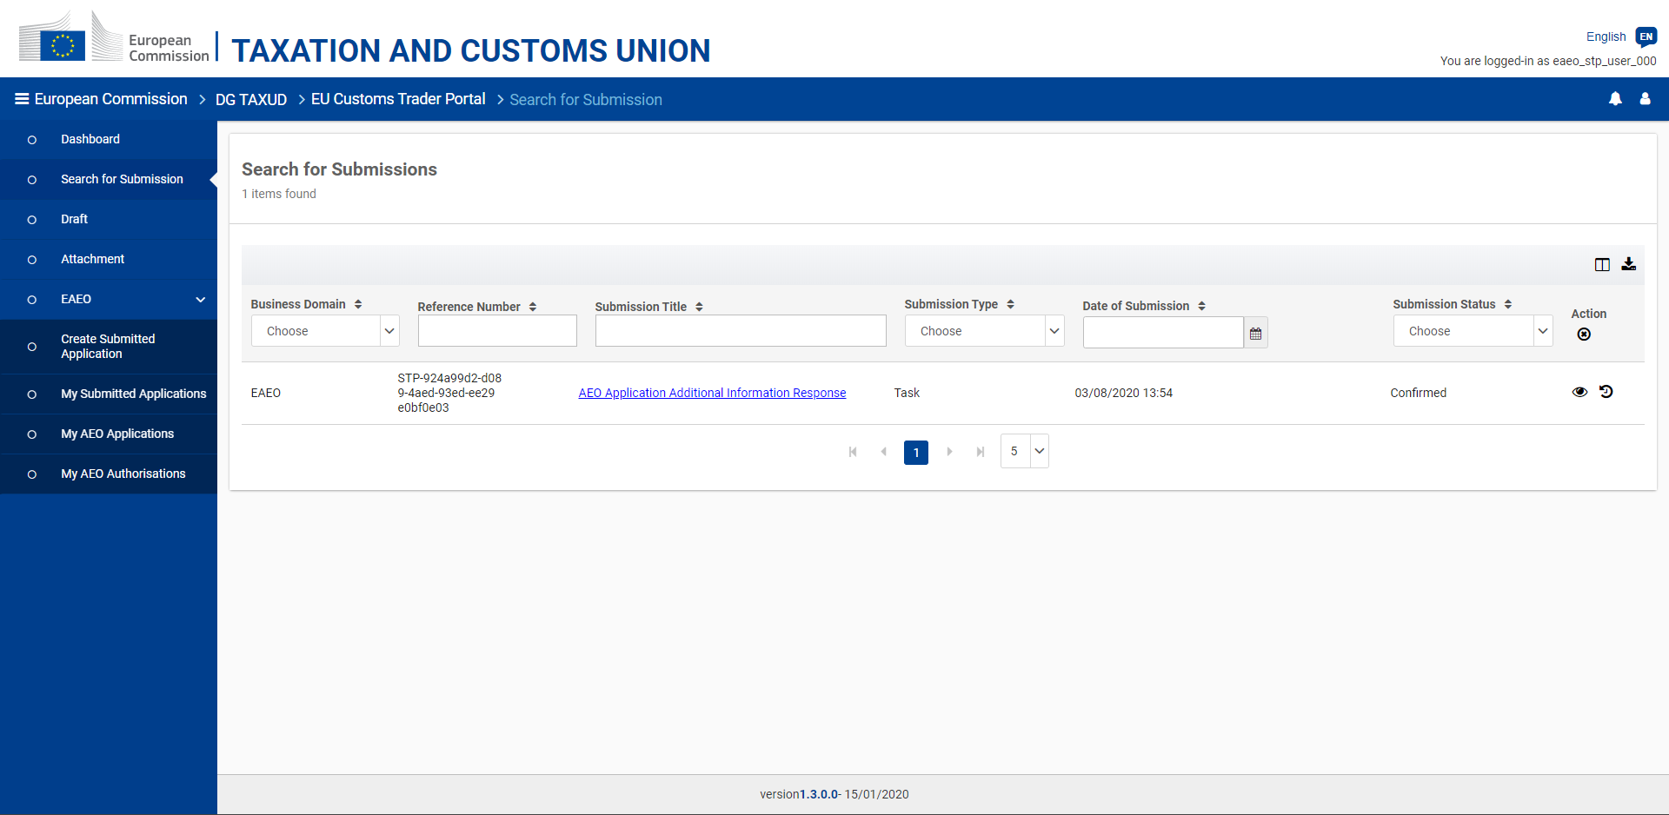
Figure 4.4.2 - AEO Application Additional Information - View submissions

The response to an AEO application additional information request can be consulted from the submitted task (EUCTP "Dashboard" menu entry) or from the list of submissions (EUCTP "Submissions" menu entry - cf. Figure 4.4.2).
4.5. Adjustments

1. Adjustments request

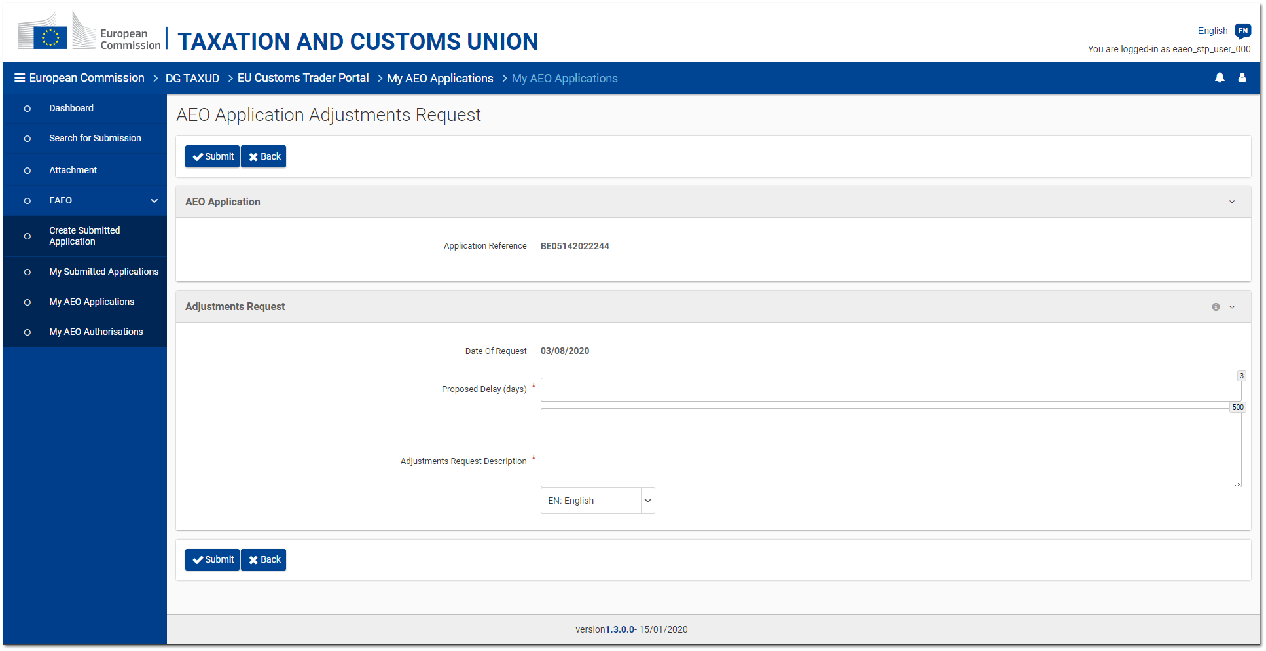
Figure 4.5.1 - AEO Application Adjustments request page

The Trader has the possibility to request a delay for implementing adjustments in his/her company.
Such a request can be issued by clicking on the "Request adjustments" button from the AEO application consultation page (cf. 4.1. Consultation).

The adjustments request page displays:
- the reference of the AEO application concerned by the adjustments;
- the proposed delay to implement the adjustments (expressed in days);
- the description of the proposed adjustments.

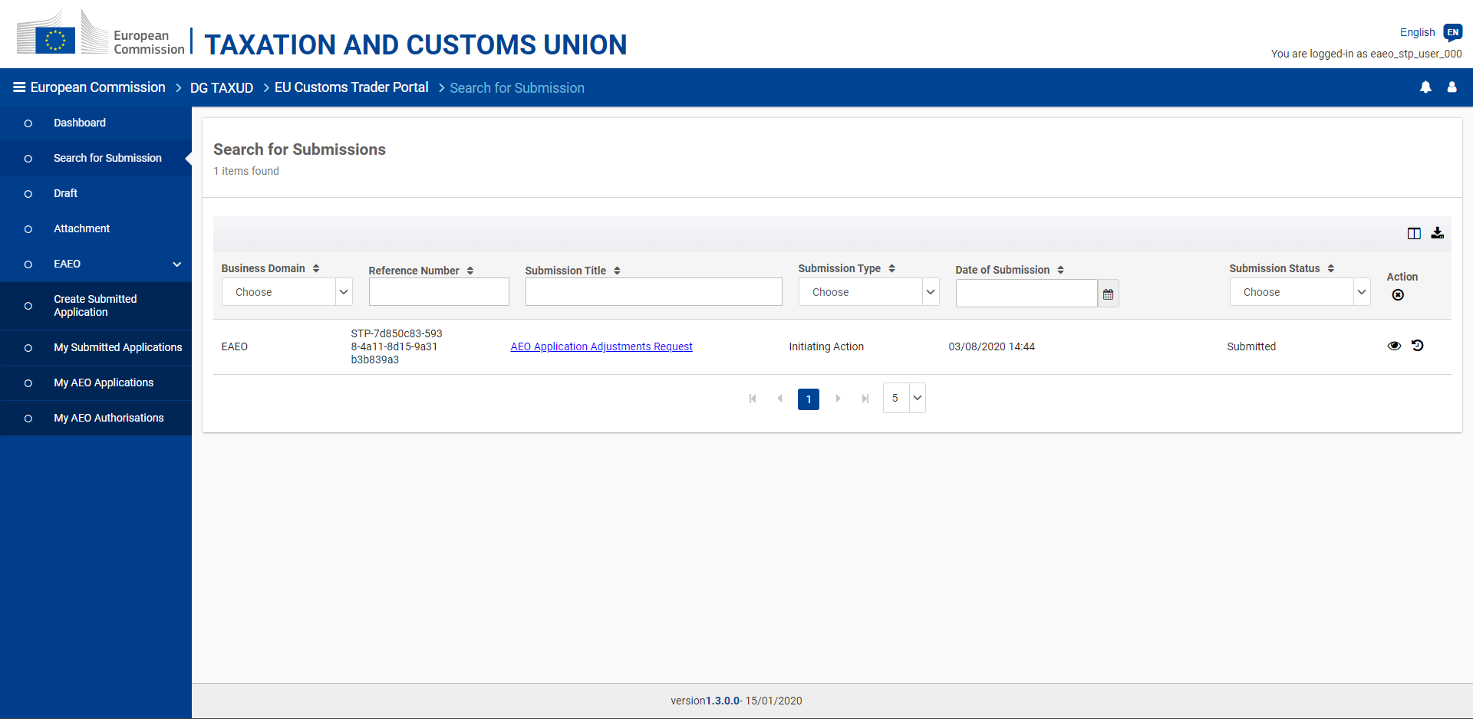
Figure 4.5.2 - AEO Application Adjustments request - View submissions

The submission of an AEO application adjustments request can be consulted from the EUCTP "Submissions" menu entry.

2. Adjustments results

The request for adjustments sent by the Trader can be accepted or rejected by the responsible Customs Authority in EOS.

The Customs Authority's response is received as:
- a task (cf. Figure 4.5.3) allowing the Trader to provide the adjustments results if the request is accepted, or
- a simple notification explaining the reason of the refusal if the request is rejected.

In both cases, the response is accessible from the EUCTP "Dashboard" menu entry.

Moreover, as soon as a request is accepted, the related "Adjustments" record is visible from the AEO application consultation page (cf. 4.1. Consultation).

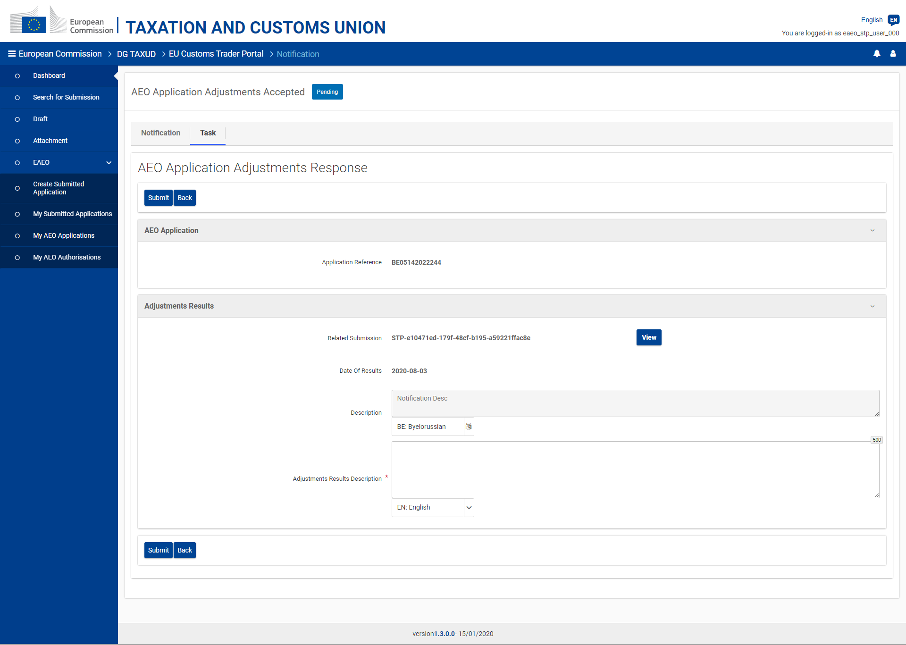
Figure 4.5.3 - AEO Application - Adjustments Response task page

If the request was accepted by the DTCA, the "Task" tab of the received notification allows the user to provide the results of the adjustments implemented within the proposed period of time. These results are provided as a textual description.

Clicking on the "View" button next to the field "Related Submission" opens the page of the adjustments request sent previously by the Trader.

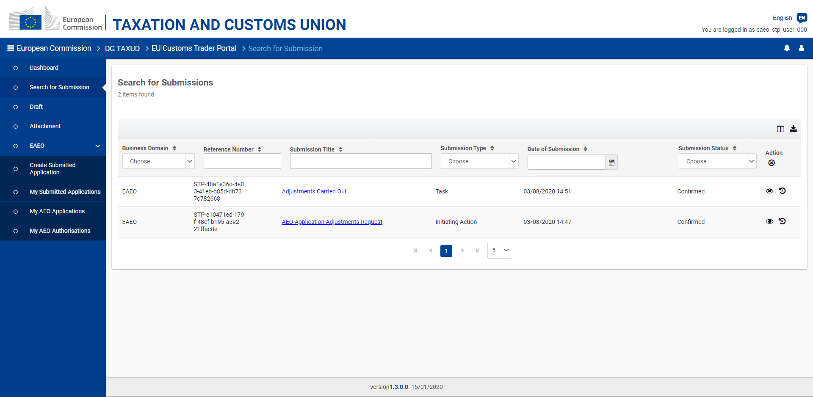
Figure 4.5.4 - AEO Application Adjustments - View submissions

The response to an AEO application adjustments request can be consulted from the submitted task (EUCTP "Dashboard" menu entry) or from the list of submissions (EUCTP "Submissions" menu entry - cf. Figure 4.5.4).

4.6. Right to be heard

The Traders have the right to be heard, namely the possibility to express their opinion when a Decision-Taking Customs Authority (DTCA) intends to reject their AEO application in EOS.
This intention of rejection is received in eAEO-STP as a task accessible from the EUCTP "Dashboard" menu entry.

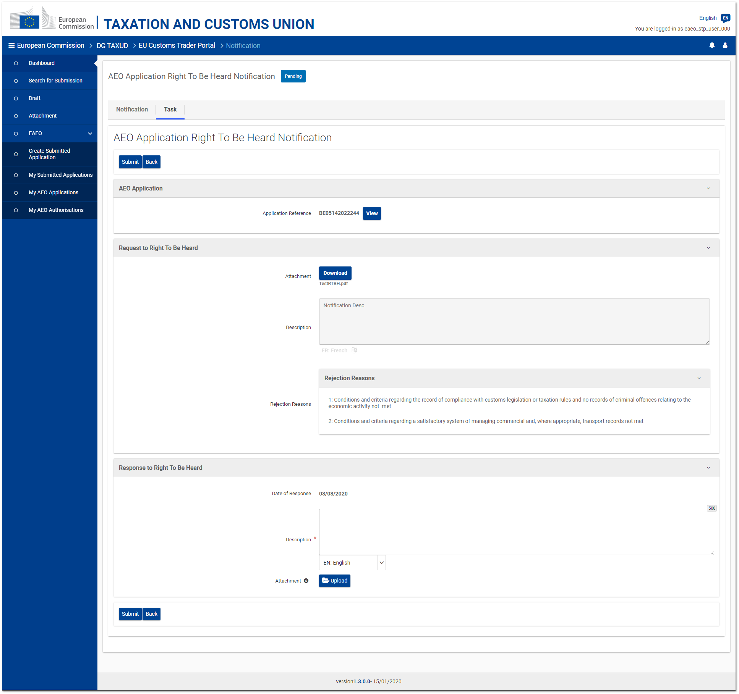
Figure 4.6.1 - AEO Application - Right to be Heard task page

The "Task" tab of the received notification displays:
- the reference of the concerned AEO application;
- the optional attachment and/or text which can be provided by the DTCA to justify his/her intention to reject this application;
- the reason(s) for which the DTCA intends to reject this application;
- an editable and mandatory text area allowing the Trader to reply in a textual format;
- a button allowing the Trader to upload an optional attachment as reply.

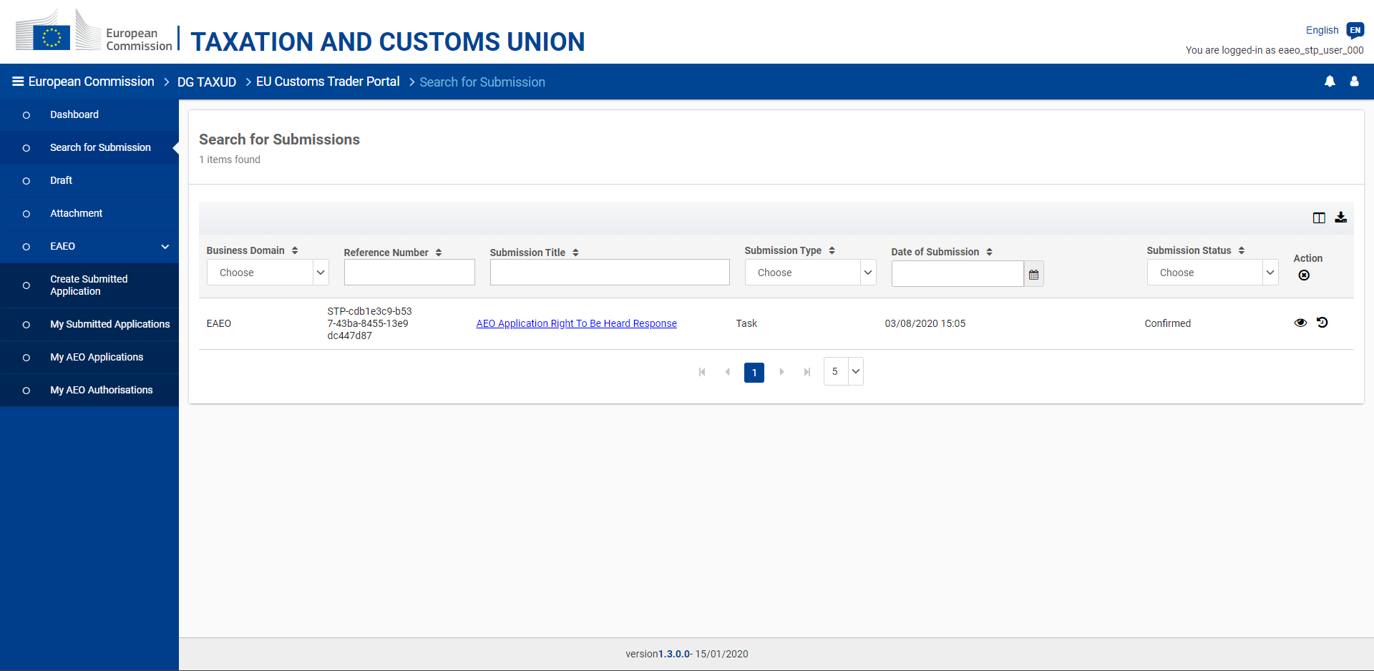
Figure 4.6.2 - AEO Application Right to be Heard - View submissions

The response to an AEO application right to be heard request can be consulted from the submitted task (EUCTP "Dashboard" menu entry) or from the list of submissions (EUCTP "Submissions" menu entry - cf. Figure 4.6.2).
5. AEO Authorisations

This section details the different pages related to the AEO authorisations.
5.1. Consultation
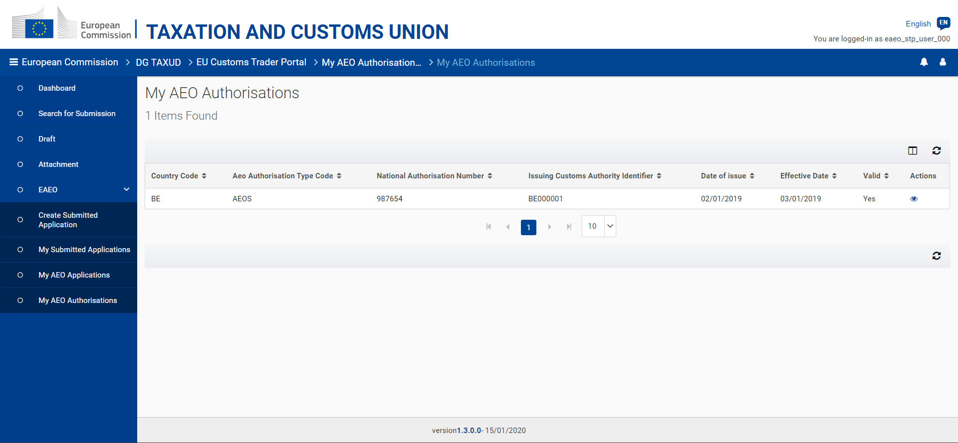
Figure 5.1.1 - My AEO Authorisations page

The list of AEO authorisations and possible previously valid AEO authorisations linked to a specific EORI can be consulted by the Trader or his/her representative by clicking on eAEO - My AEO Authorisations, accessible from the left-hand menu.
Considering that there can be only one valid AEO authorisation in all EU, the list consists of the valid AEO authorisation and possible previous non valid AEO authorisations.

Summarized information about every AEO authorisation retrieved from EOS can be seen. From this page, it is possible to consult the details of a specific AEO authorisation.

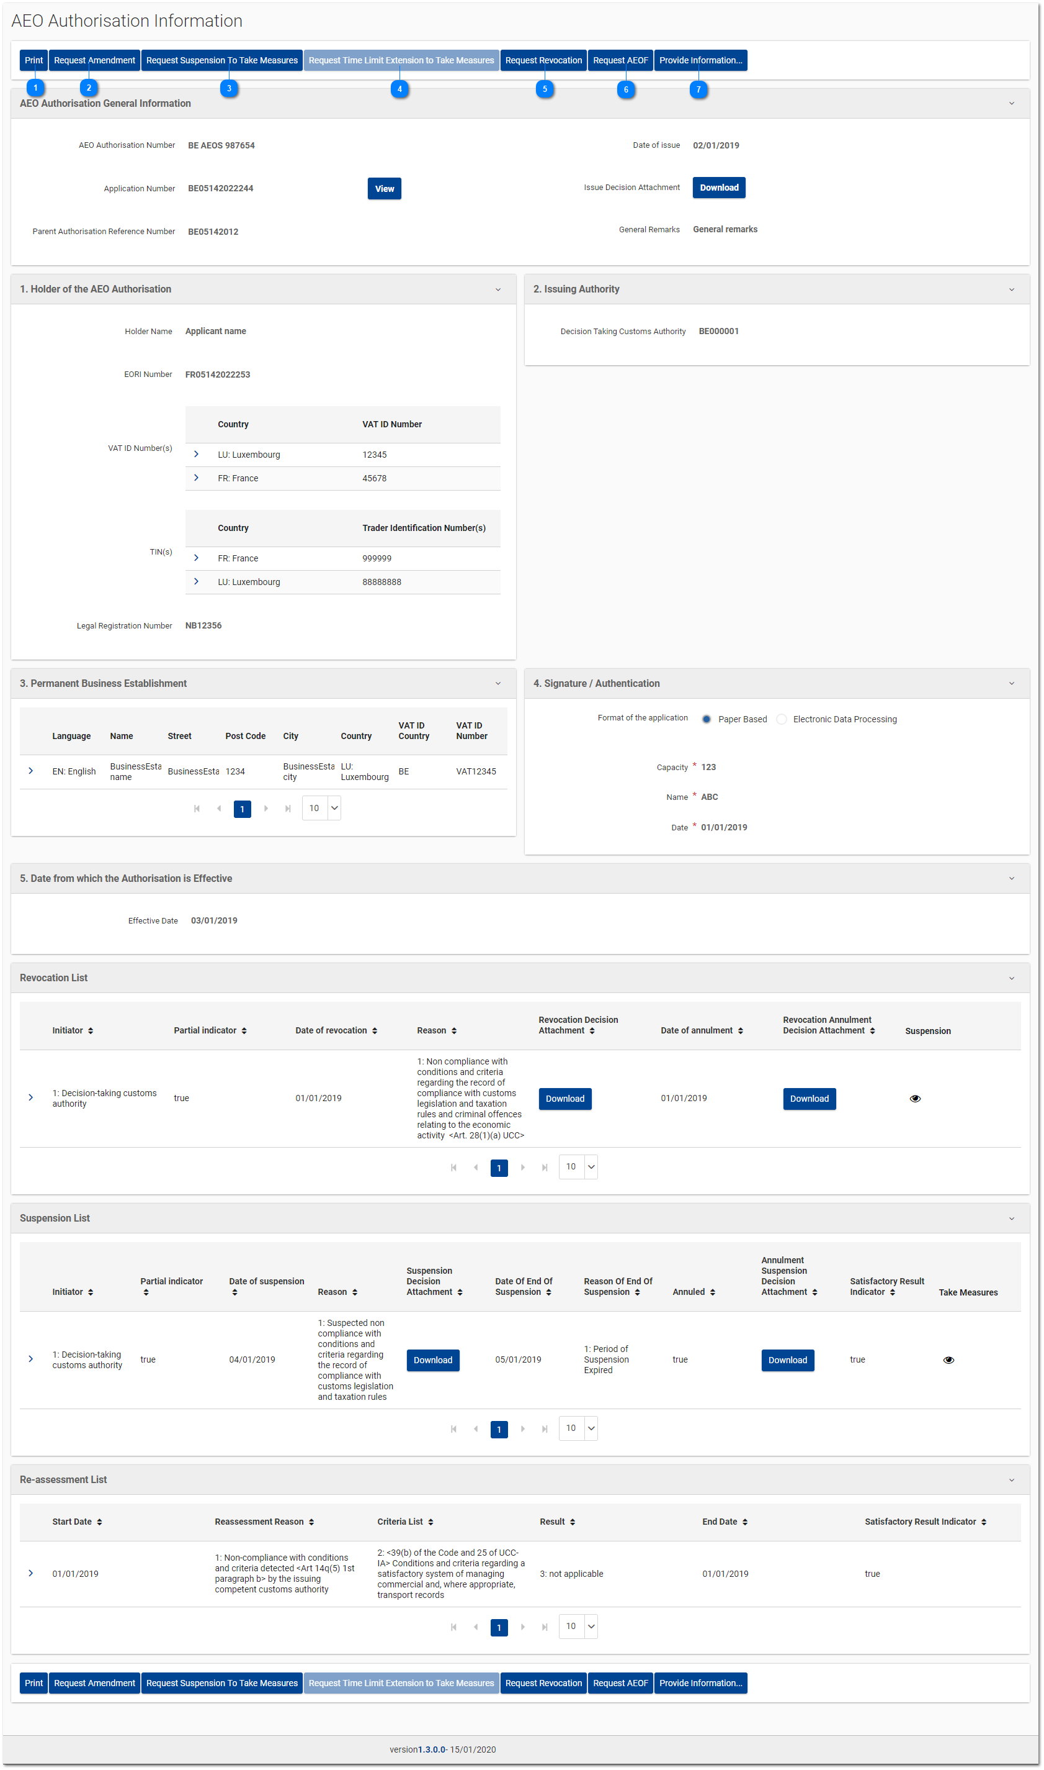
Figure 5.1.2 - AEO Authorisation consultation page

This page displays the details of an AEO authorisation, including the possible suspensions, revocations and re-assessments linked to it.

Depending on the current status of the consulted AEO authorisation, some actions can be performed on it:

Generate a PDF of the AEO Authorisation;

Request an AEO authorisation amendment (cf. 5.2. Amendment);

Request suspension to take measures (cf. 5.3. Suspension & Take Measures);


Request extension of the time limit to take measures (cf. 5.3. Suspension & Take Measures);


Request the AEO authorisation revocation (cf. 5.4. Revocation);


Upgrade the AEO authorisation to AEOF (cf. 3.7. Request AEOF);


Provide information which may influence the continuation of the decision (cf. 5.5. Provide information which may influence the continuation of the decision).

5.2. Amendment
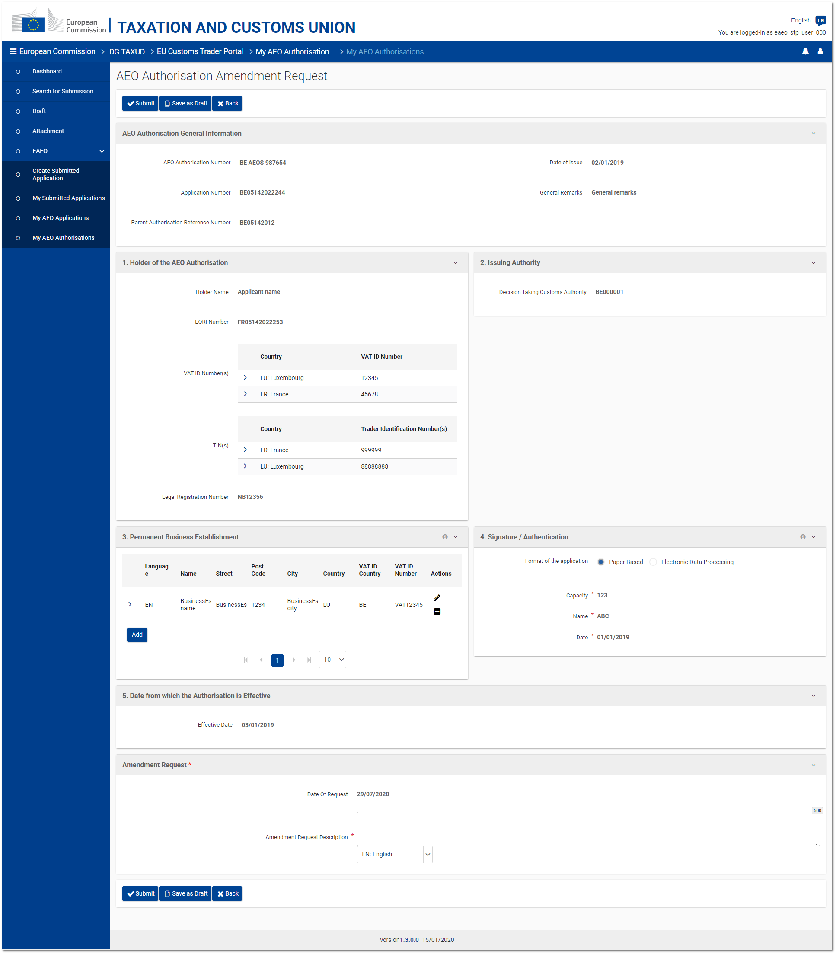
Figure 5.2.1 - AEO Authorisation Amendment request page

The amendment of an AEO authorisation may be requested under certain conditions – the authorisation is valid (i.e. not suspended or revoked) and the related Member State has no NTP – by clicking on the "Request amendment" button from the AEO authorisation consultation page (cf. 5.1. Consultation).

The page displays the same fields as in the visualisation page and some of them are editable.
An additional box "Amendment Request description" is displayed at the bottom of the page to allow users specifying a justification for the amendment request.

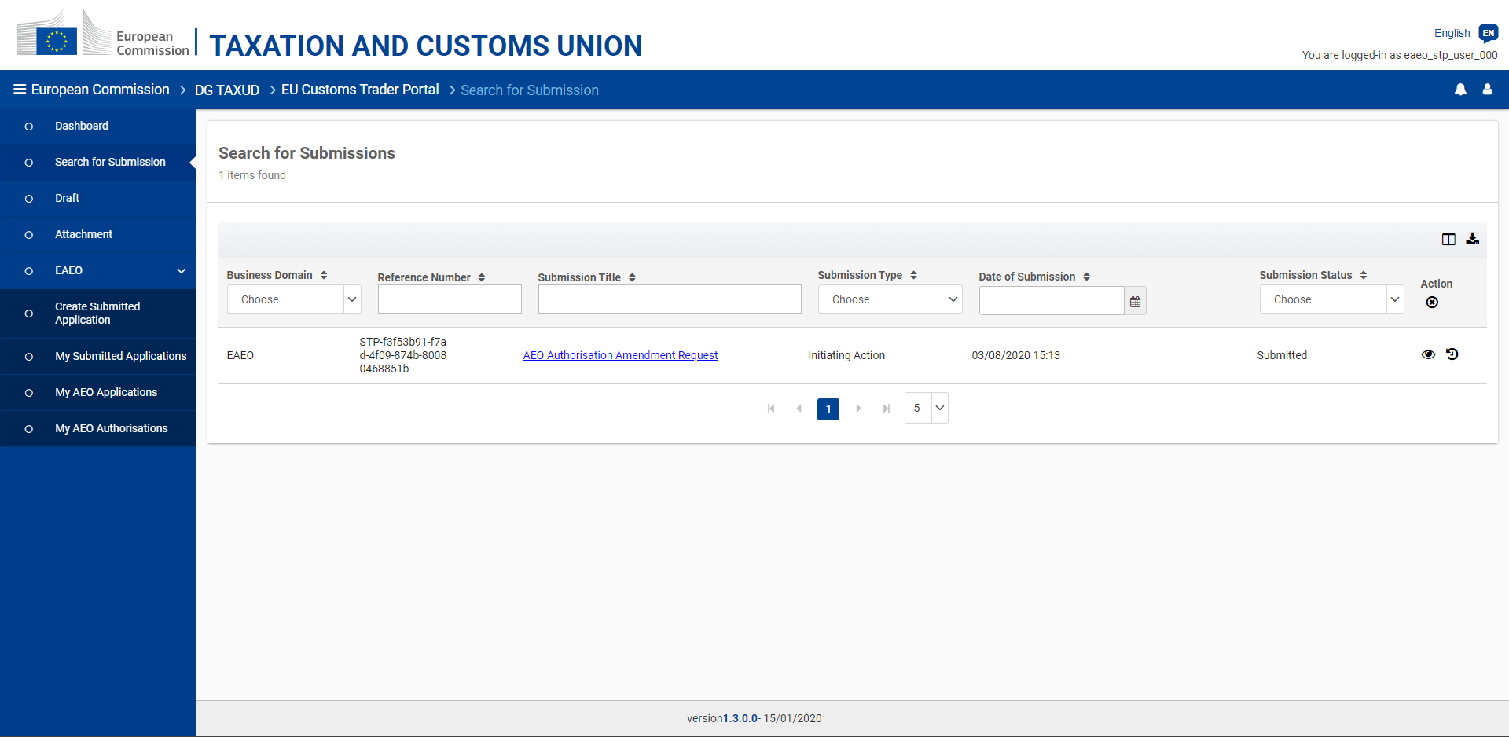
Figure 5.2.2 - AEO Authorisation Amendment request - View submissions

The submission of an AEO authorisation amendment request can be consulted from the EUCTP "Submissions" menu entry.
5.3. Suspension & Take Measures

Traders have the possibility to request a delay for taking measures in their company or can be requested by the competent Customs Authority to take measures.

During this period of time, their AEO authorisation must be suspended.
5.3.1. Proposed measures

1. Request from the Trader:

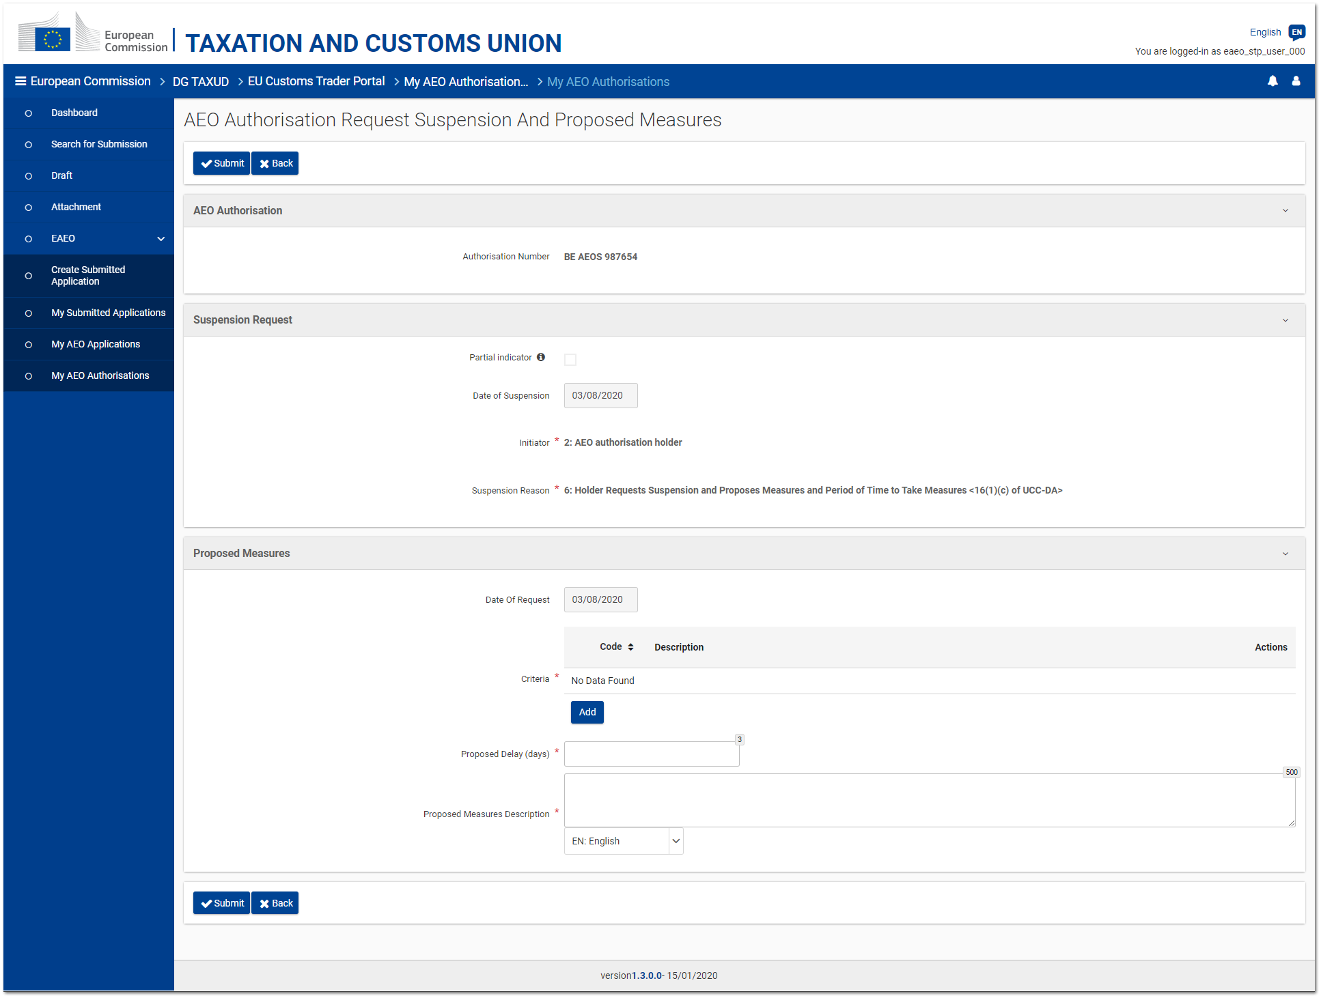
Figure 5.3.1.1 - AEO Authorisation Request Suspension and Proposed Measures page

The Trader has the possibility to request the suspension of his/her AEO authorisation for taking measures.
Such a request can be issued by clicking on the "Request Suspension To Take Measures" button from the AEO authorisation consultation page (cf. 5.1. Consultation).

The request page displays the following elements:
- the reference of the AEO authorisation concerned by the request;
- the suspension partial indicator (only editable for 'AEOF' authorisations);
- the non-editable details of the suspension request (i.e. date of suspension, initiator and suspension reason);
- the criteria for which the measures should be taken;
- the proposed delay to implement the proposed measures (expressed in days);
- the description of the measures proposed by the Trader.

In case of partial suspension (partial indicator must be enabled), the selected criteria must belong to only one of the following categories:
- Security (i.e. 4*);
- Practical standards of competence and professional qualifications (i.e. 5*).

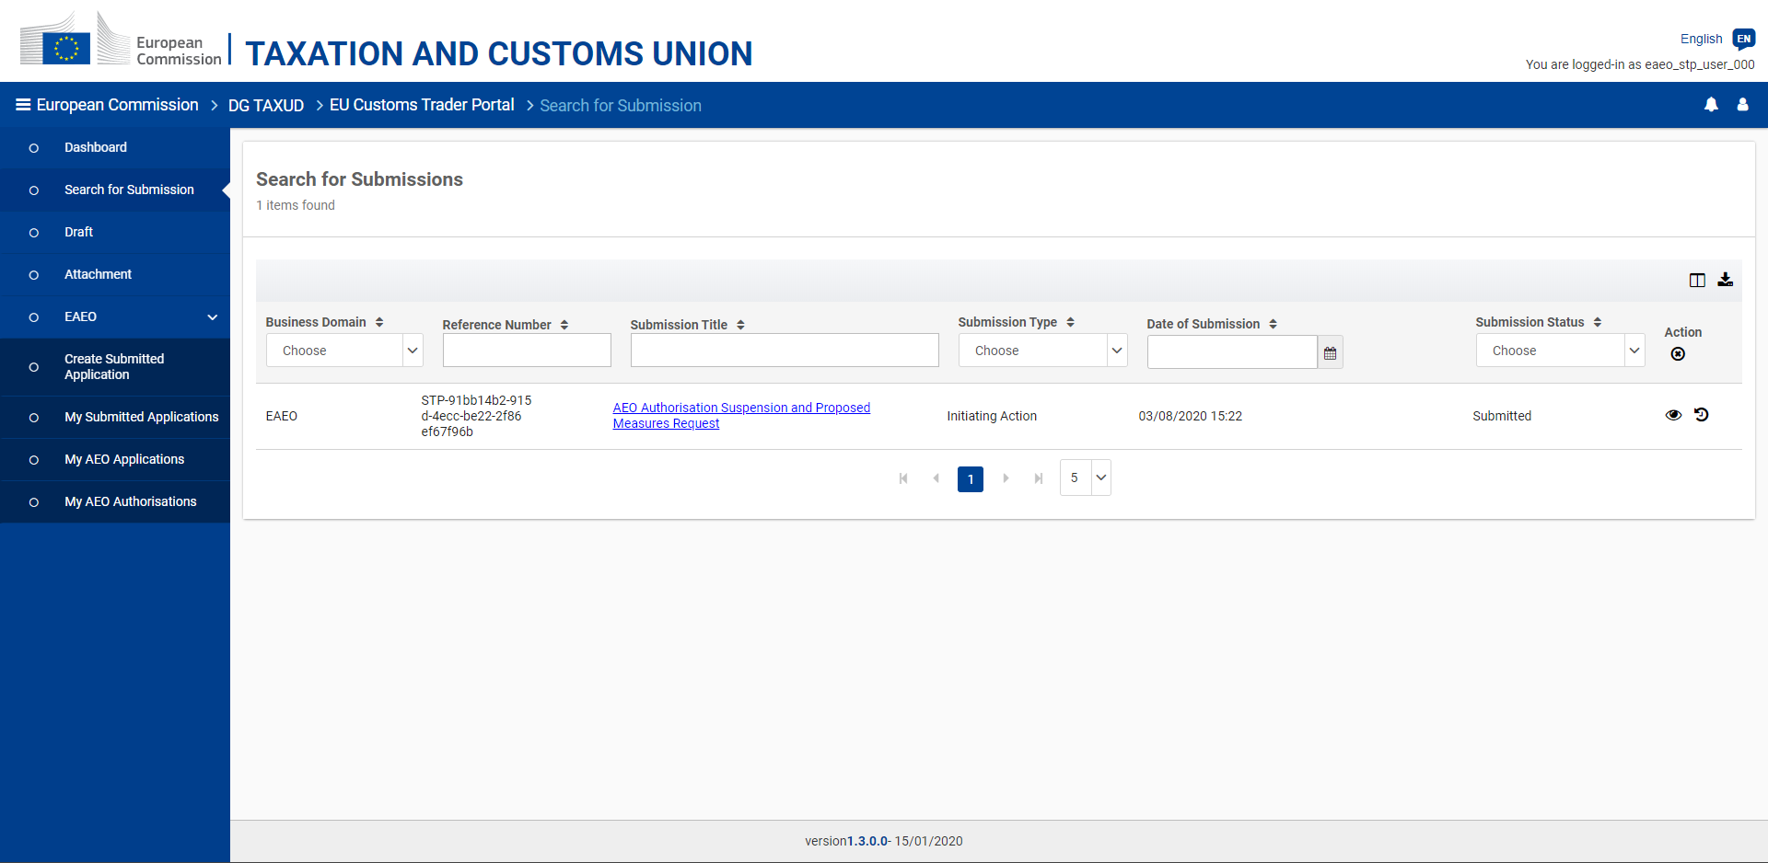
Figure 5.3.1.2 - AEO Authorisation Take Measures request - View submissions

The submission of an AEO application adjustments request can be consulted from the EUCTP "Submissions" menu entry.

2. Request from the Customs Authority:

The Trader may also be requested to take measures by the Customs Authority in EOS.
Such a request for taking measures is received in eAEO-STP as a task accessible from the EUCTP "Dashboard" menu entry.

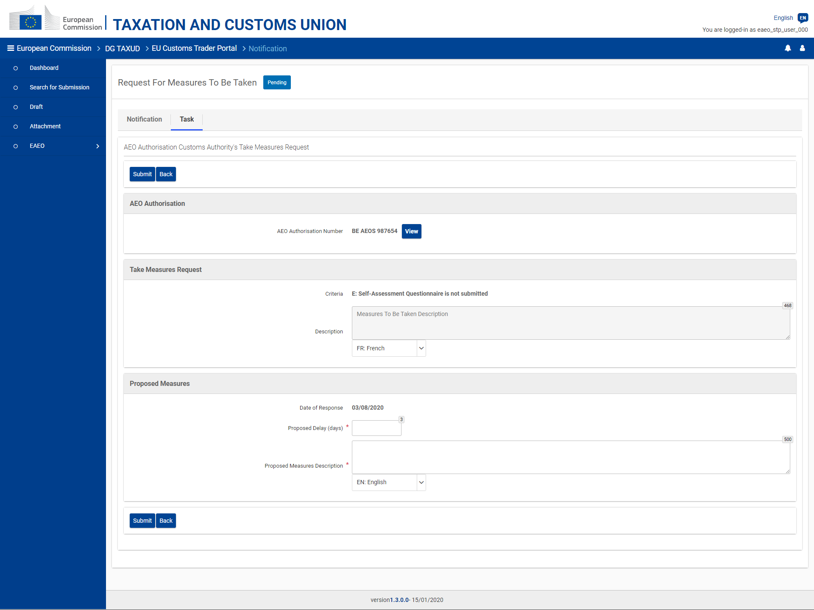
Figure 5.3.1.3 - AEO Authorisation - Measures to be Taken task page

The "Task" tab of the received notification displays the following elements:
- the reference of the AEO authorisation concerned by the request;
- read-only information provided by the Customs Authority about the request (criteria and textual description);
- the delay (expressed in days) proposed by the Trader to implement the proposed measures;
- the description of the measures proposed by the Trader.

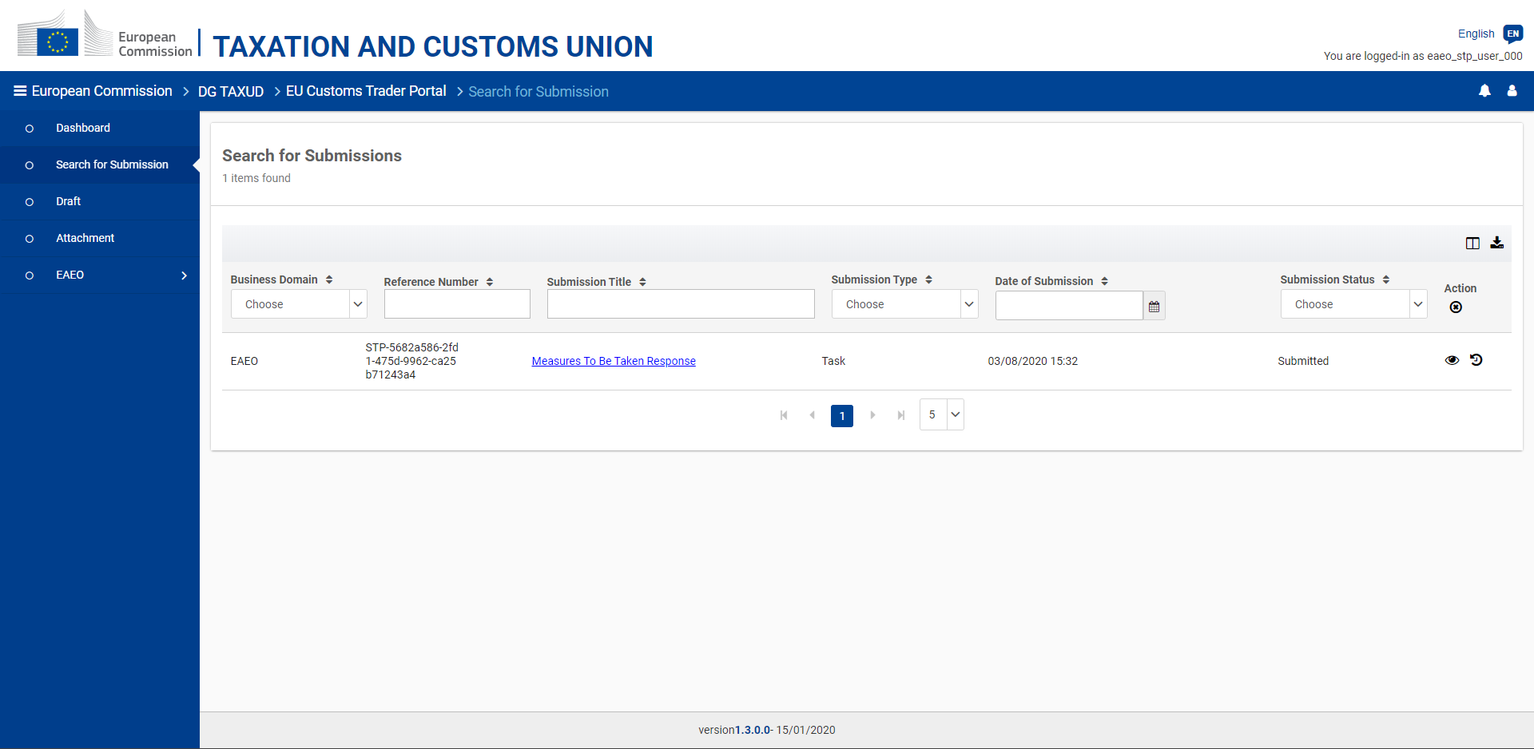
Figure 5.3.1.4 - AEO Authorisation Take Measures response - View submissions

The response to a Customs Authority's request for taking measures can be consulted from the submitted task (EUCTP "Dashboard" menu entry) or from the list of submissions (EUCTP "Submissions" menu entry - cf. Figure 5.3.1.4).
5.3.2. Measures taken

The proposed measures sent by the Trader, either on his/her own initiative or as a reply to the Customs Authority's request (cf. 5.3.1. Proposed measures), can be accepted or rejected by the responsible Customs Authority in EOS.

The Customs Authority's response is received as:
- a task (cf. Figure 5.3.2.1) allowing the Trader to provide the measures taken if the proposed measures was accepted, or
- a simple notification explaining the reason of the refusal if the request was rejected.

In both cases, the response is accessible from the EUCTP "Dashboard" menu entry.

Moreover, as soon as the proposed measures are accepted, the related "Take Measures" record is visible from the AEO authorisation consultation page (cf. 5.1. Consultation) on the related suspension record.

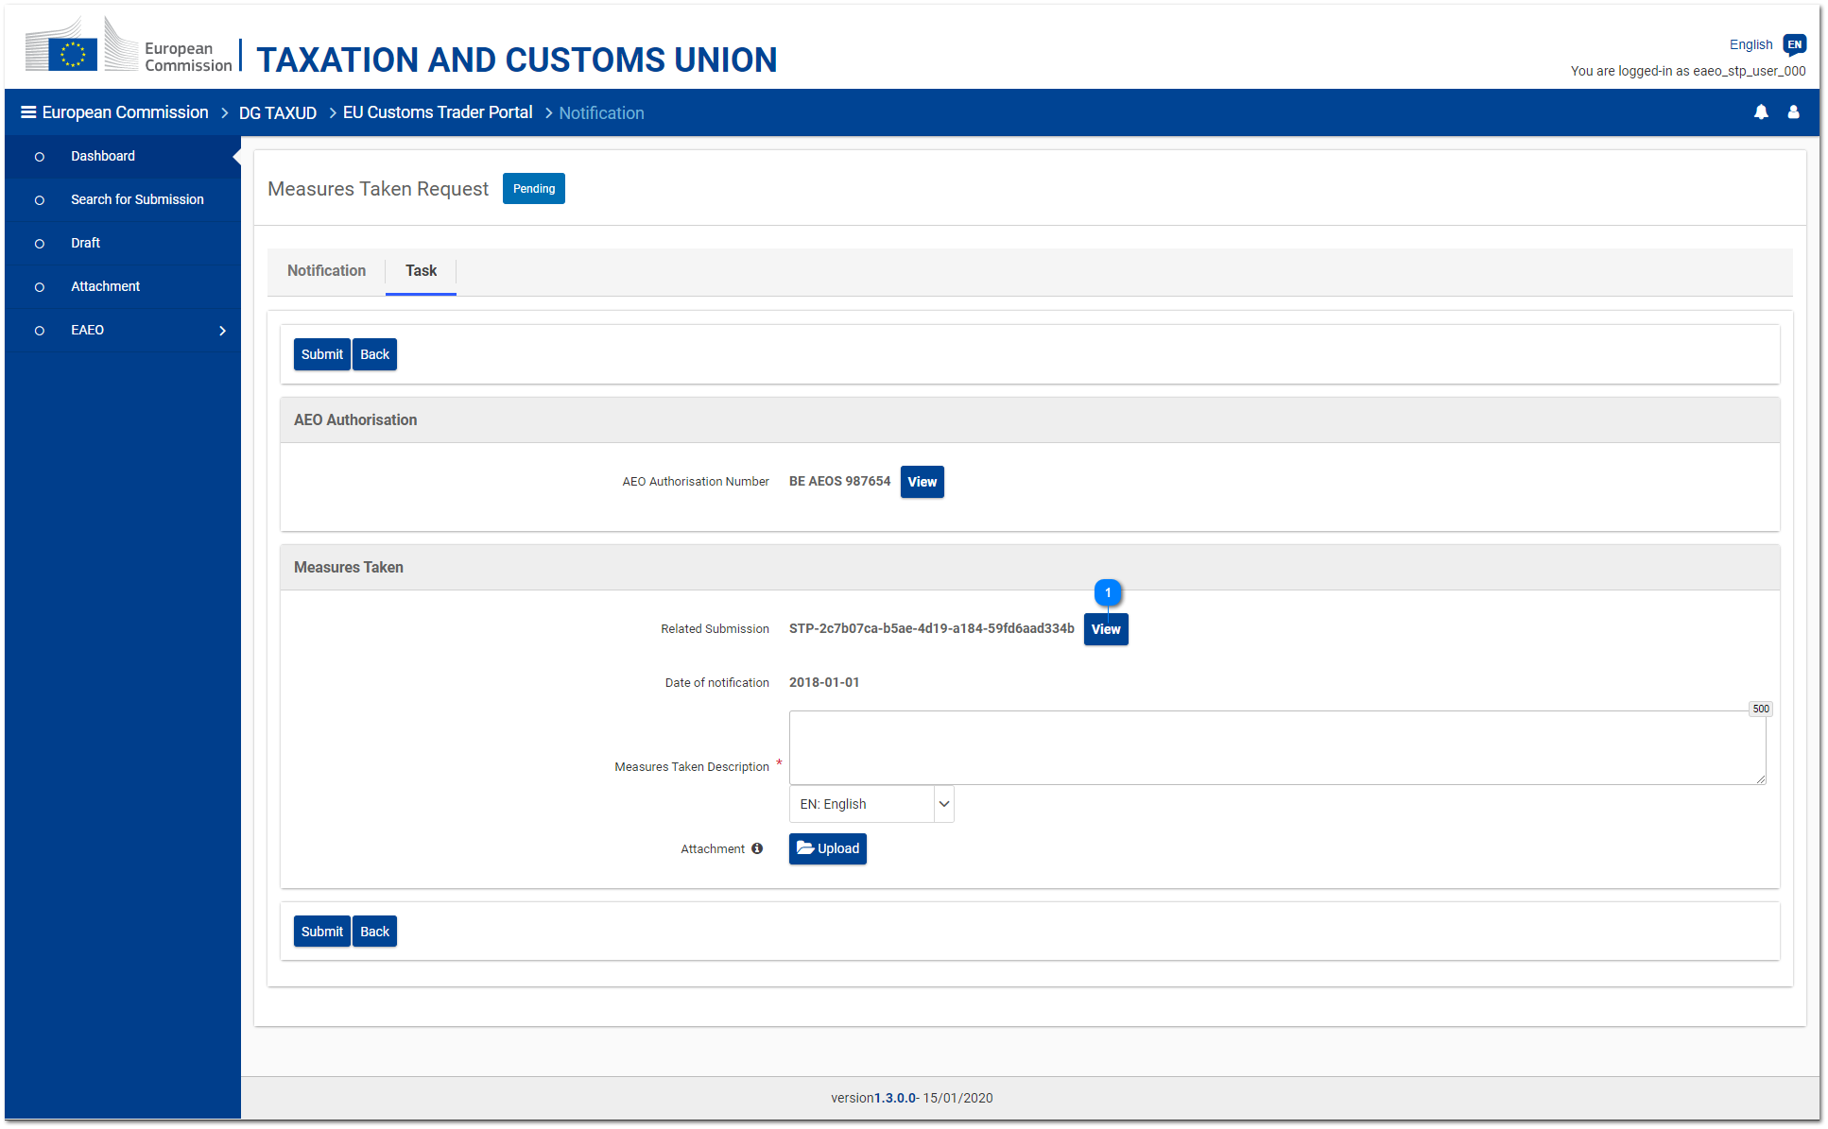
Figure 5.3.2.1 - AEO Authorisation - Proposed Measures Response task page

If the proposed measures were accepted by the Customs Authority, the "Task" tab of the received notification allows the user to provide the measures taken within the proposed period of time. These measures are provided as a textual description. An attachment can also be uploaded by the Trader as evidence for the measures taken.

Clicking on the "View" button next to the field "Related Submission" opens the page of the proposed measures sent previously by the Trader.

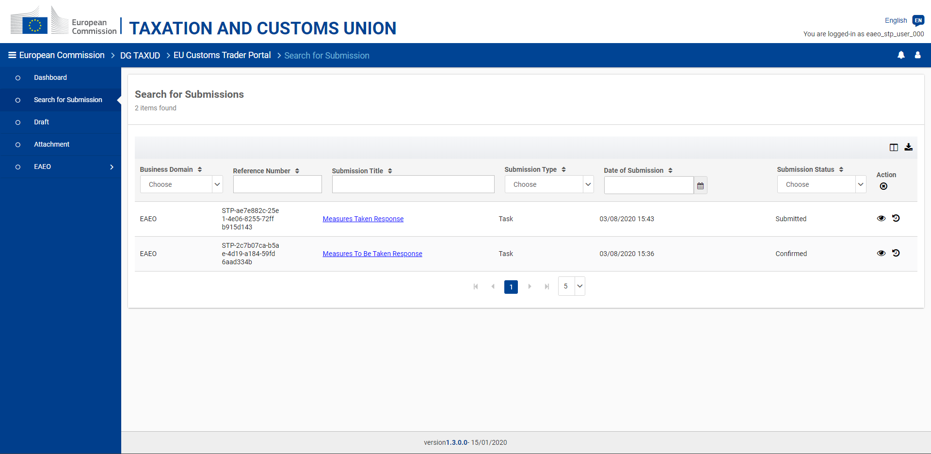
Figure 5.3.2.2 - AEO Authorisation Measures Taken - View submissions

The measures taken submission can be consulted from the submitted task (EUCTP "Dashboard" menu entry) or from the list of submissions (EUCTP "Submissions" menu entry - cf. Figure 5.3.2.2).
5.3.3. Take measures extension

1. Extension request

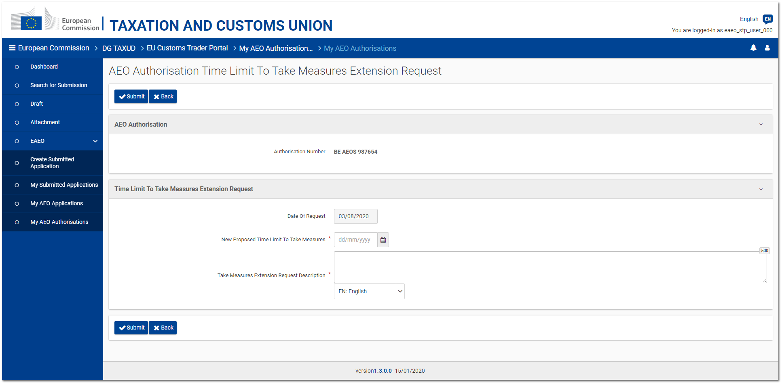
Figure 5.3.3.1 - AEO Authorisation Take Measures Extension request page

As long as a task for providing the measures taken (cf. 5.3.2. Measures taken) is not expired, the Trader may request the extension of this task.
The goal is to ask for an extra delay to implement the proposed measures (cf. 5.3.1. Proposed measures).
Such a request can be submitted to the competent Customs Authority by clicking on the "Request Time Limit to Take Measures Extension" button from the AEO authorisation consultation page (cf. 5.1. Consultation).

The page provides the following elements:
- the reference of the AEO authorisation concerned by the request;
- the new proposed time limit to implement the measures (expressed as a date);
- a textual description for explaining the reason of the request.

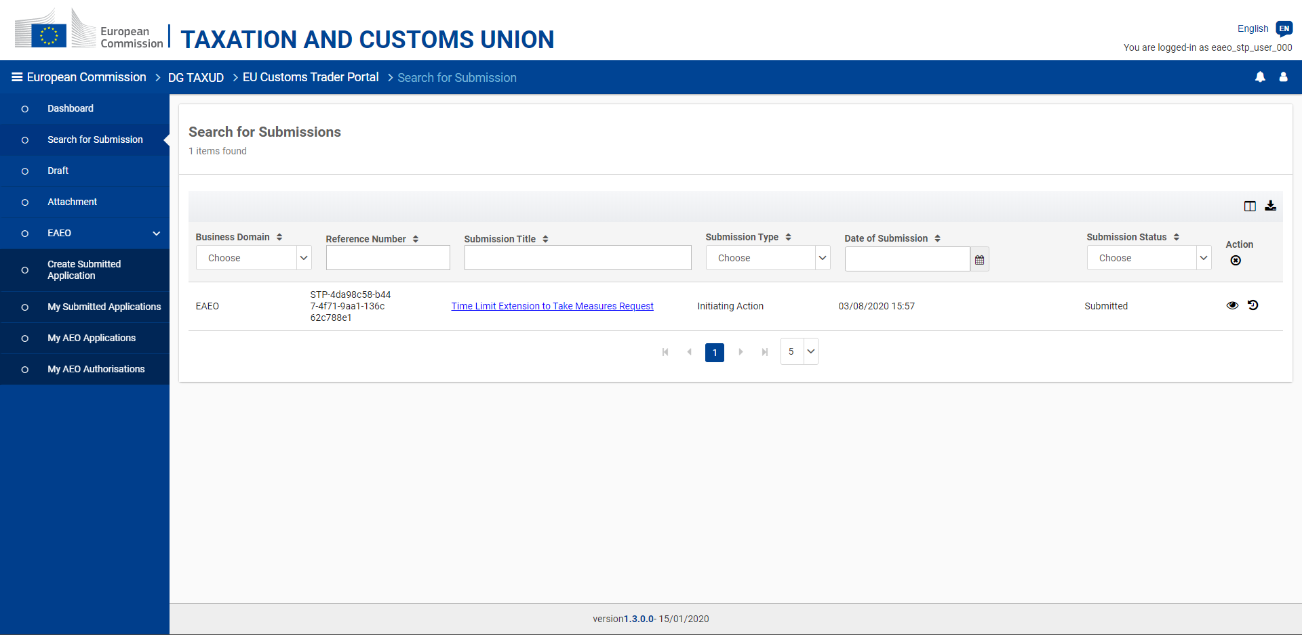
Figure 5.3.3.2 - Authorisation Take Measures Extension request - View submissions

The submission of an AEO authorisation take measures extension request can be consulted from the EUCTP "Submissions" menu entry.

2. Extension response

The request for extension sent by the Trader can be accepted or rejected by the Customs Authority in EOS.

The Customs Authority's response is received as a simple notification explaining the decision.
This notification will also extend the time limit of the "measures taken" task (cf. 5.3.2. Measures taken) to the proposed date if the request was accepted.

In both cases, the response is accessible from the EUCTP "Dashboard" menu entry.
5.4. Revocation

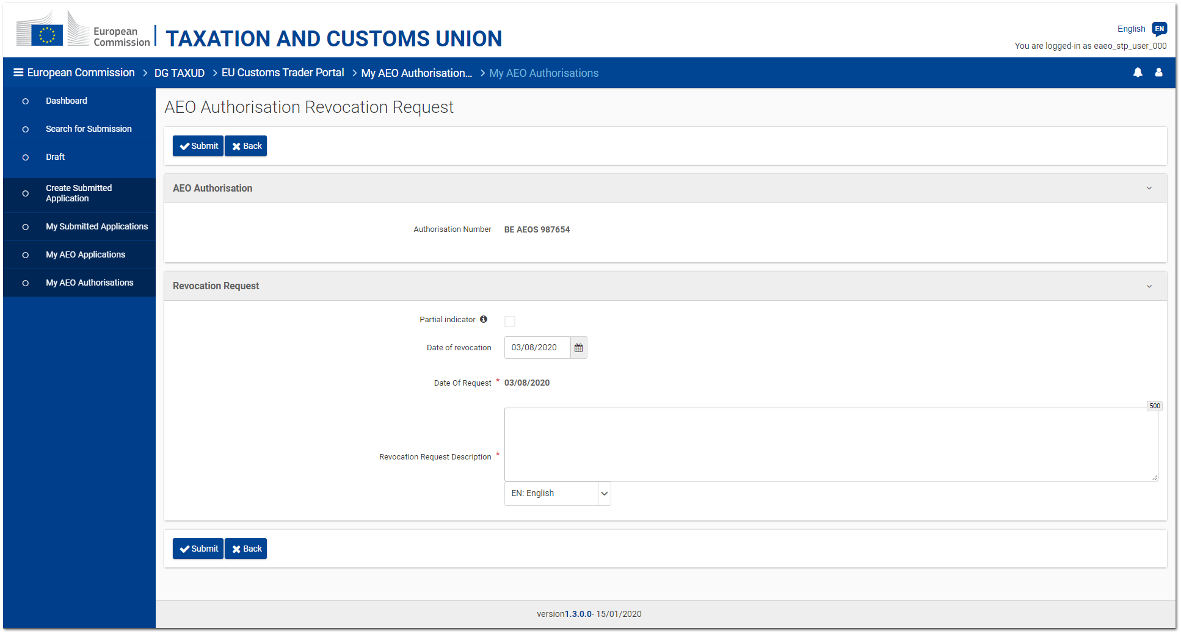
Figure 5.4.1 - AEO Authorisation Revocation request page

The revocation of a valid AEO authorisation may be requested by clicking on the "Request revocation" button from the AEO authorisation consultation page (cf. 5.1. Consultation).

The page displays the following elements:
- the reference of the AEO authorisation concerned by the request;
- the revocation partial indicator (only editable for 'AEOF' authorisations)
- the requested revocation date;
- a mandatory justification for the revocation request.

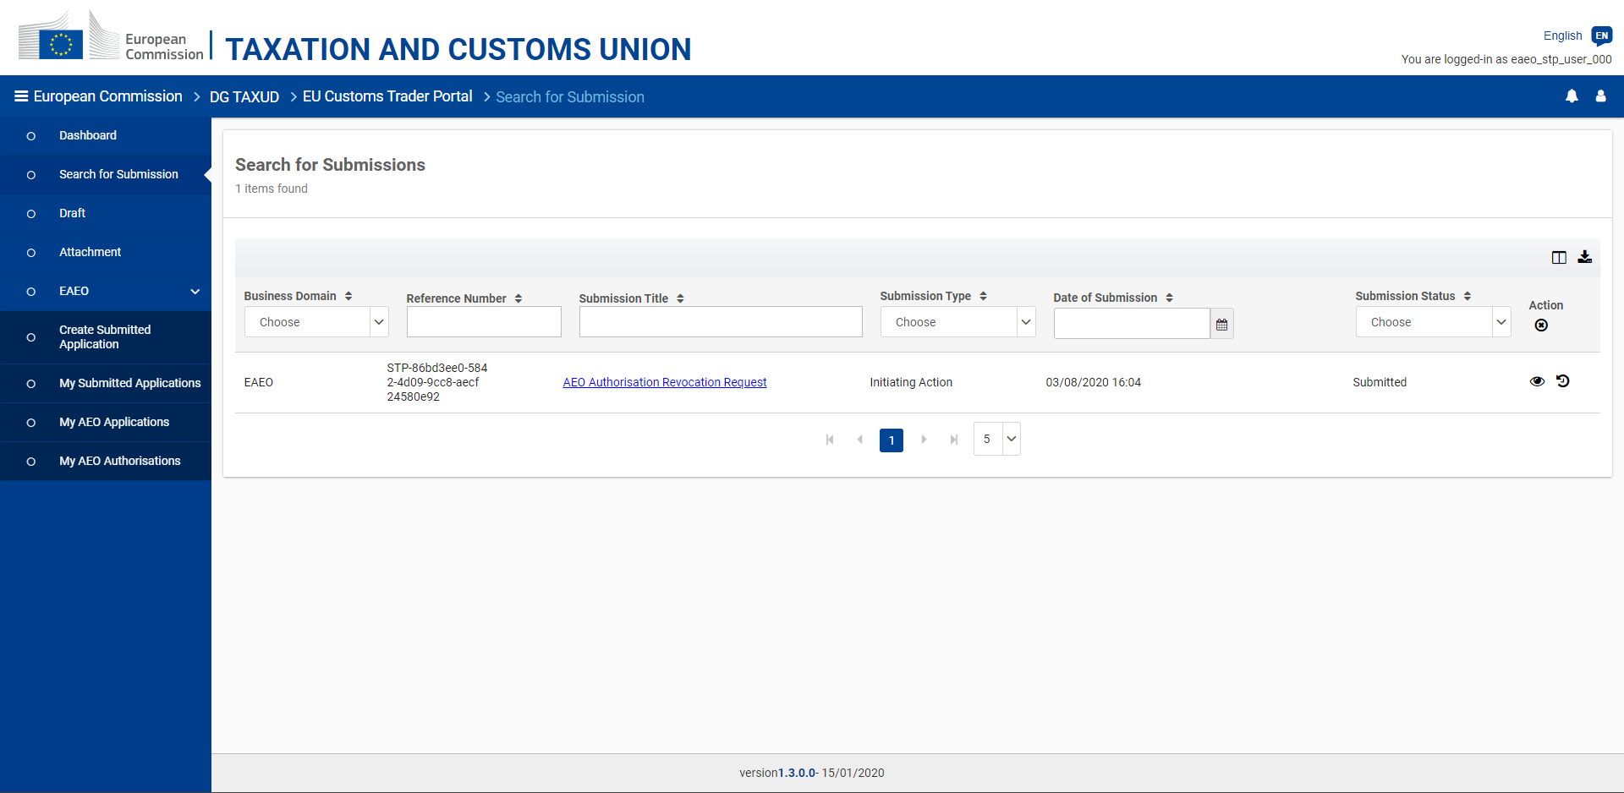
Figure 5.4.2 - AEO Authorisation Revocation request - View submissions

The submission of an AEO authorisation revocation request can be consulted from the EUCTP "Submissions" menu entry.
5.5. Provide information which may influence the continuation of the decision

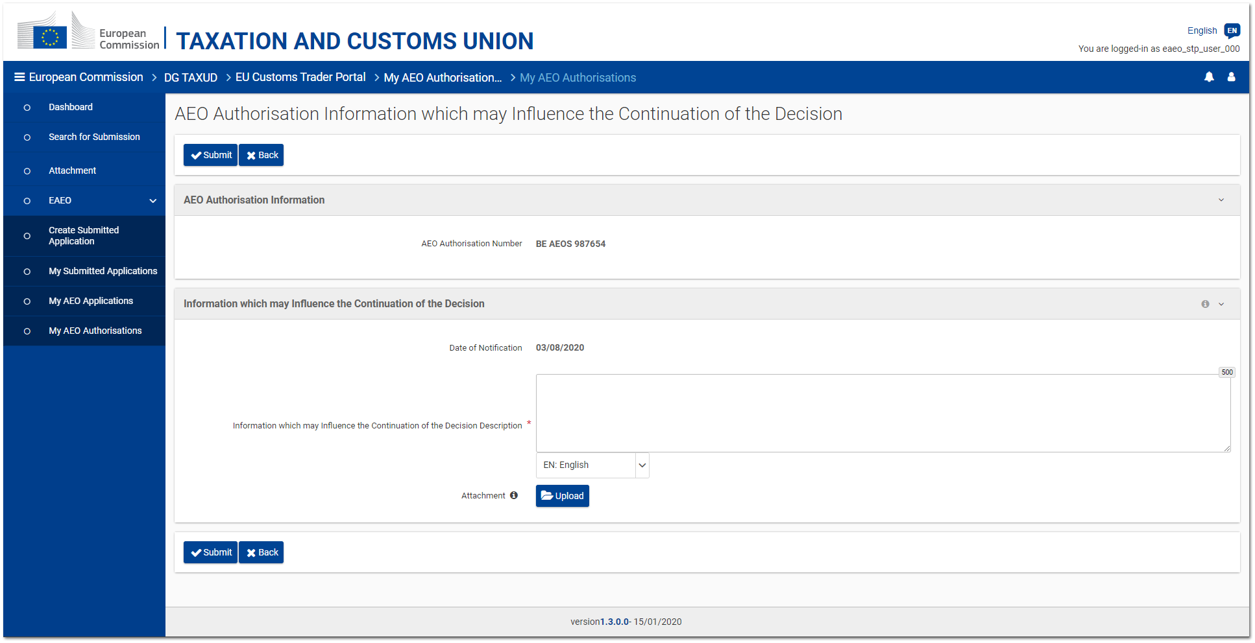
Figure 5.5.1 - AEO Authorisation - "Provide information which may influence the continuation of the decision" page

The Trader has the possibility to communicate to the responsible Customs Authority some information which may influence the continuation of the decision.
This operation can be done by clicking on the "Provide information which may influence the continuation of the decision" button from the AEO authorisation consultation page (cf. 5.1. Consultation).

The page provides an editable field allowing the Trader to enter a textual description of the information he/she wants to communicate to the Customs Authority. Furthermore, an attachment can be transmitted.

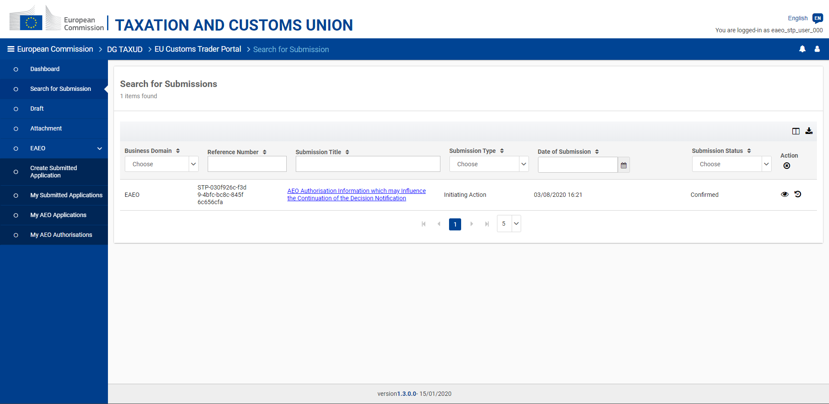
Figure 5.5.2 - AEO Authorisation "Provide information which may influence the continuation of the decision" - View submissions

The submission of such a communication can be consulted from the EUCTP "Submissions" menu entry.
5.6. Right to be heard

The Traders have the right to be heard, namely the possibility to express their opinion when a Customs Authority (DTCA) intends to suspend or revoke their AEO authorisation in EOS.
This intention of suspension or revocation is received in eAEO-STP as a task accessible from the EUCTP "Dashboard" menu entry.

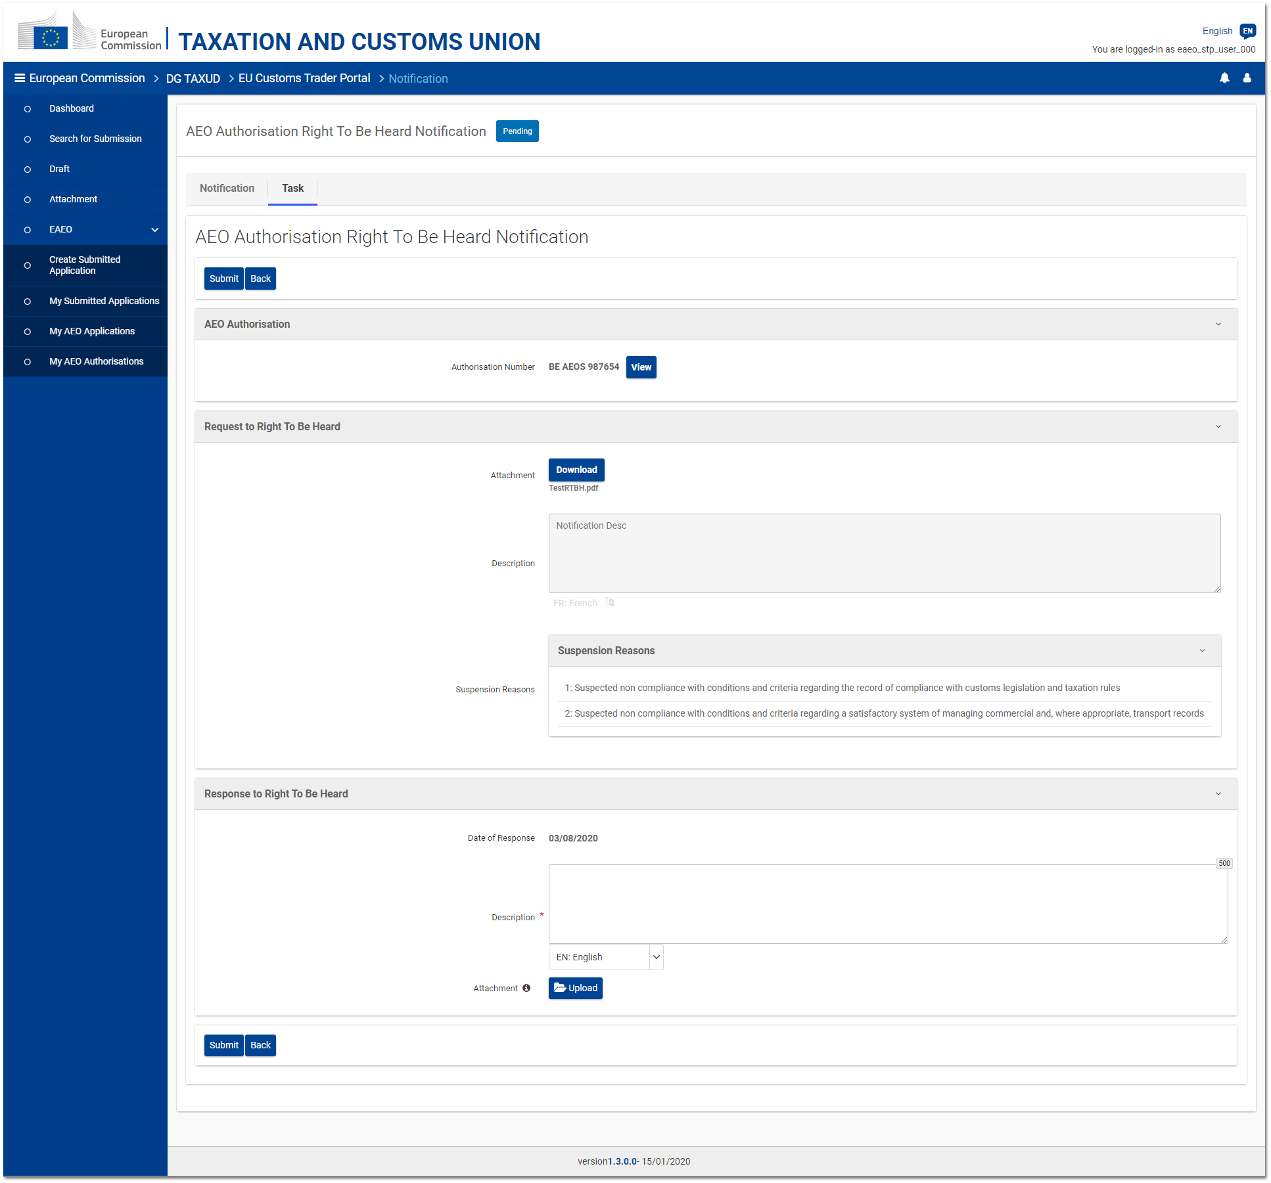
Figure 5.6.1 - AEO Authorisation - Right to be Heard task page

The "Task" tab of the received notification displays:
- the reference of the concerned AEO authorisation;
- the optional attachment and/or text that can be provided by the DTCA to justify his/her intention to suspend or revoke this authorisation;
- the reason(s) for which the Customs Authority intends to suspend or revoke this authorisation;
- an editable and mandatory text area allowing the Trader to reply in a textual format;
- a button allowing the Trader to upload an optional attachment as reply.

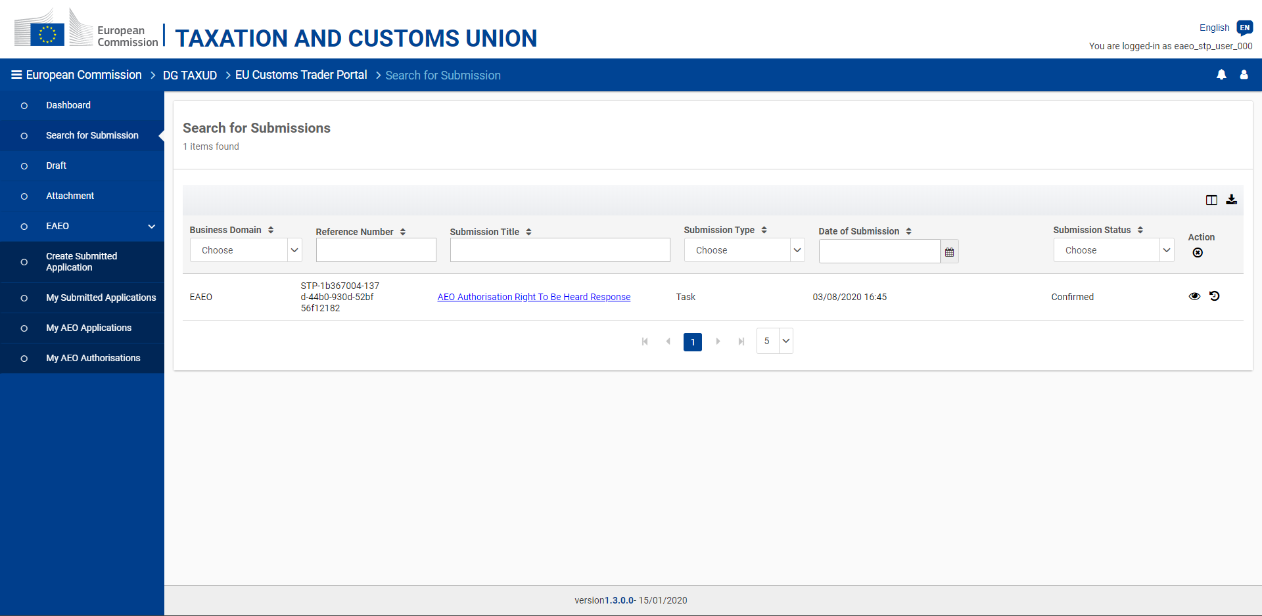
Figure 5.6.2 - AEO Authorisation Right to be Heard - View submissions

The response to an AEO authorisation right to be heard request can be consulted from the submitted task (EUCTP "Dashboard" menu entry) or from the list of submissions (EUCTP "Submissions" menu entry - cf. Figure 5.6.2).

